Day 5

1pm-5pm

Charts

🡪prepare data for chart

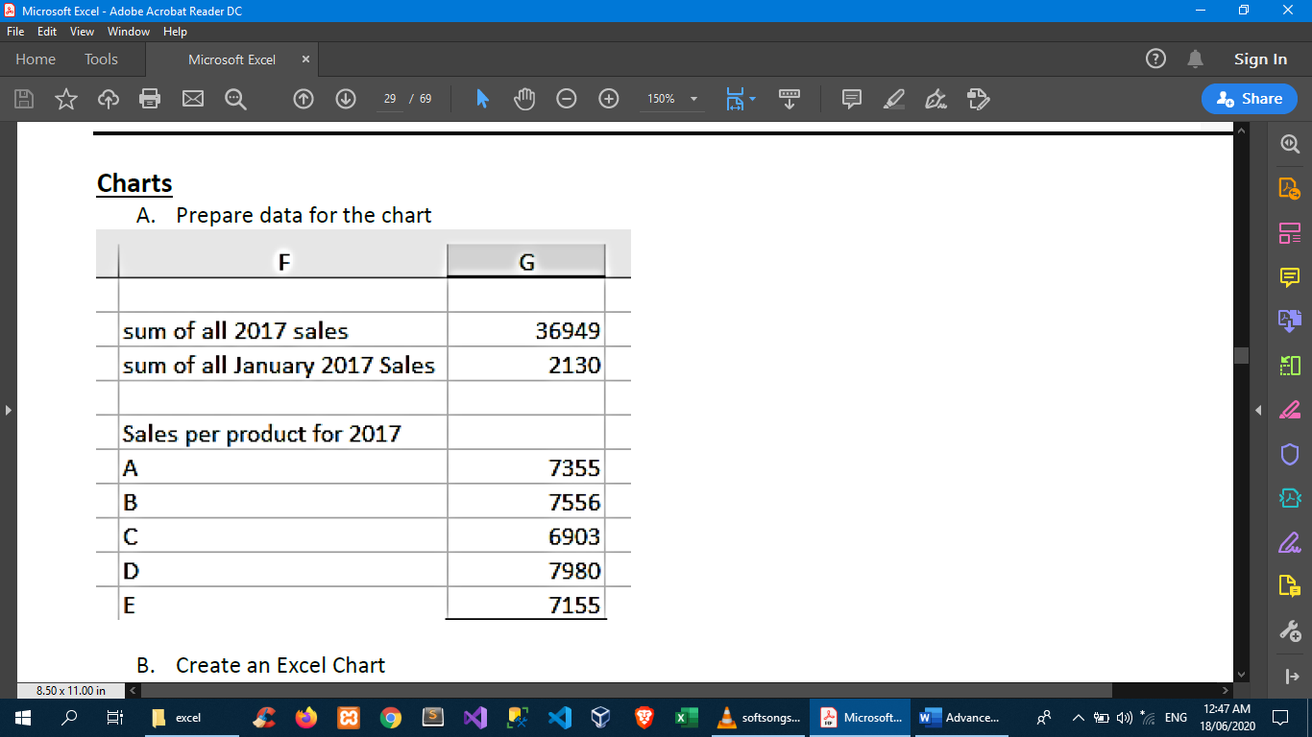

🡪highlight data range🡪insert🡪recommended charts

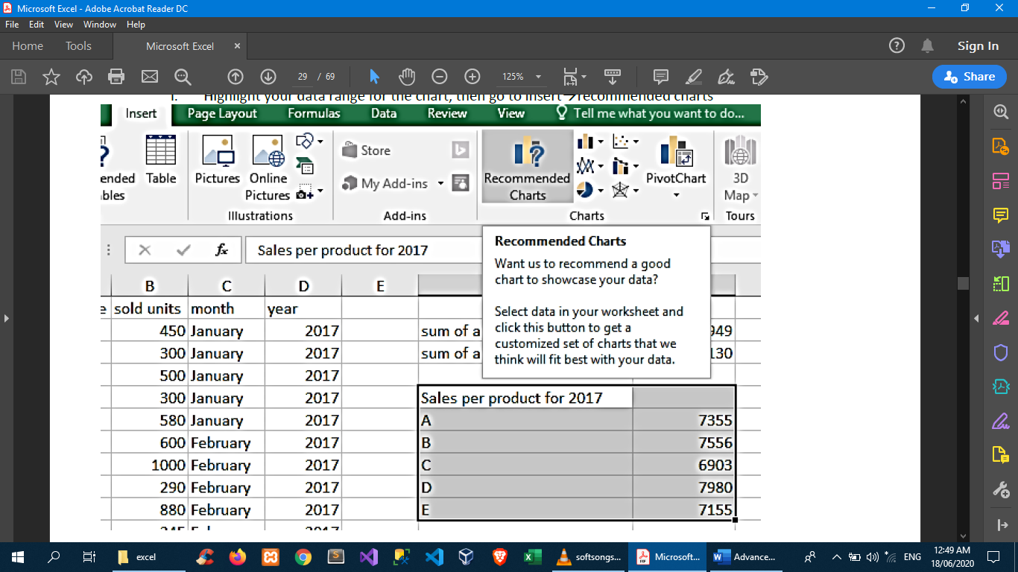

🡪choose a chart that best displays your data

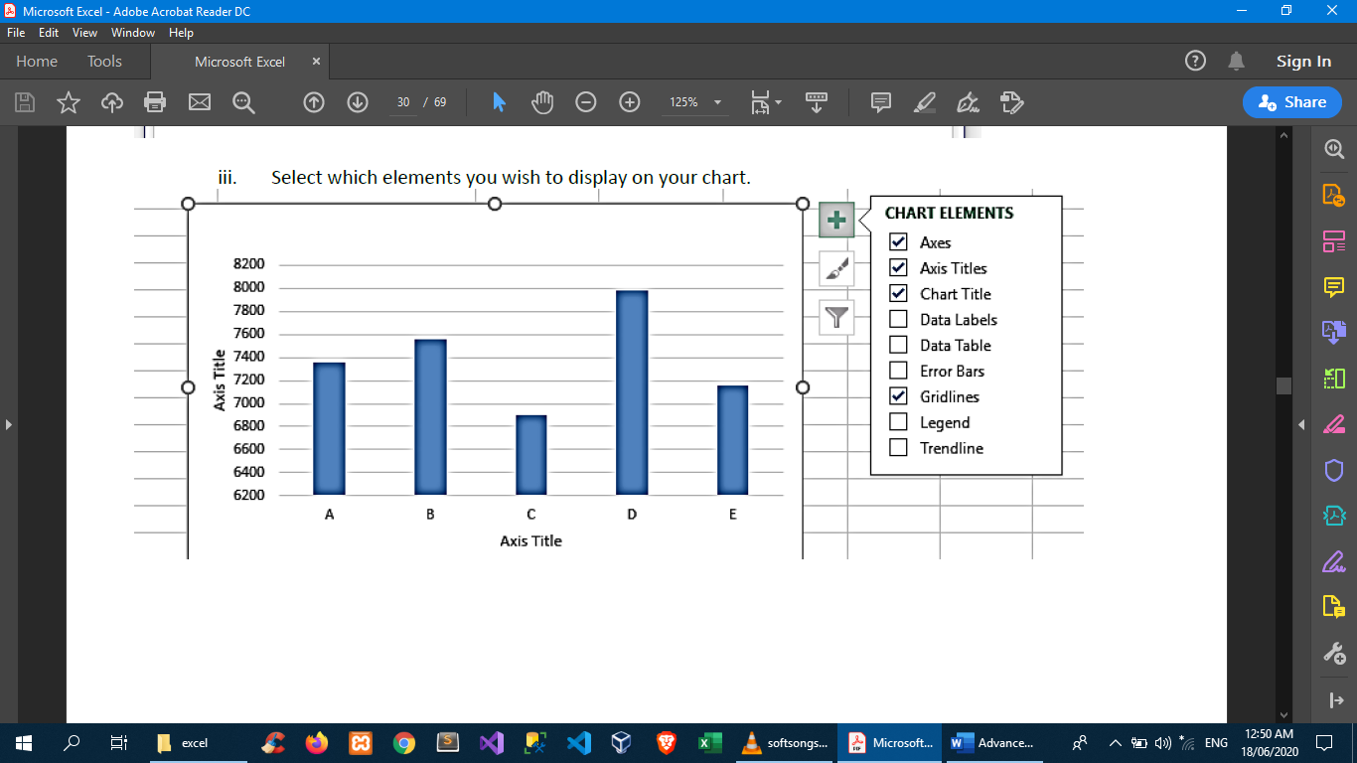

🡪try changing chart styles

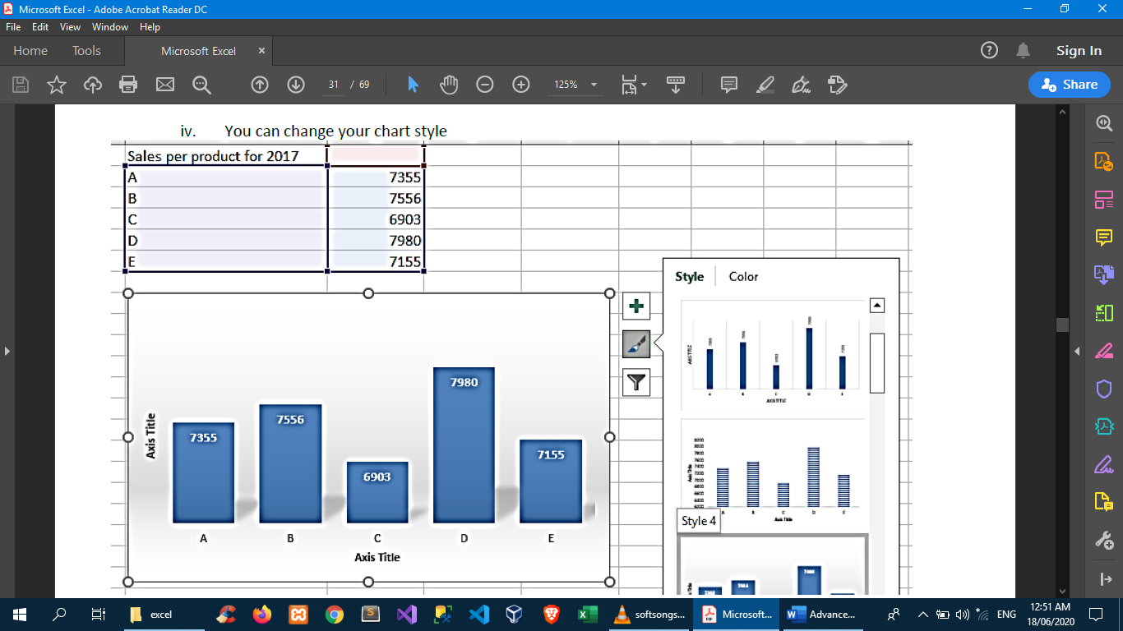

🡪try filtering display also

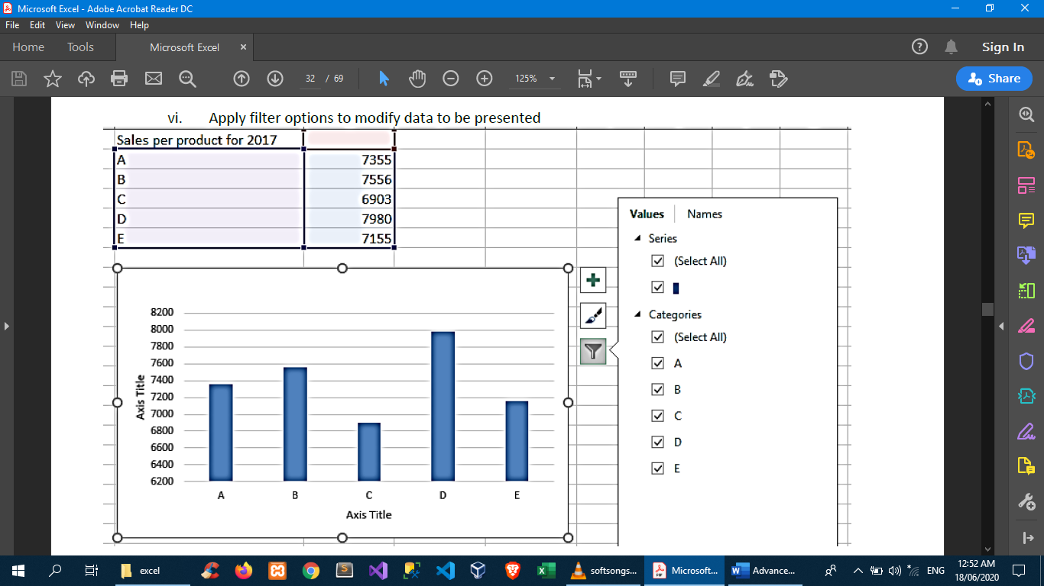

Pivot Table

Excel PivotTables are good and fast ways to present data in a variety of ways. Because of its flexibility, you don’t need to create new tables or charts for changing elements and values every time.

🡪To create a PivotTable, highlight the data range you need to present then go to insert🡪pivot table

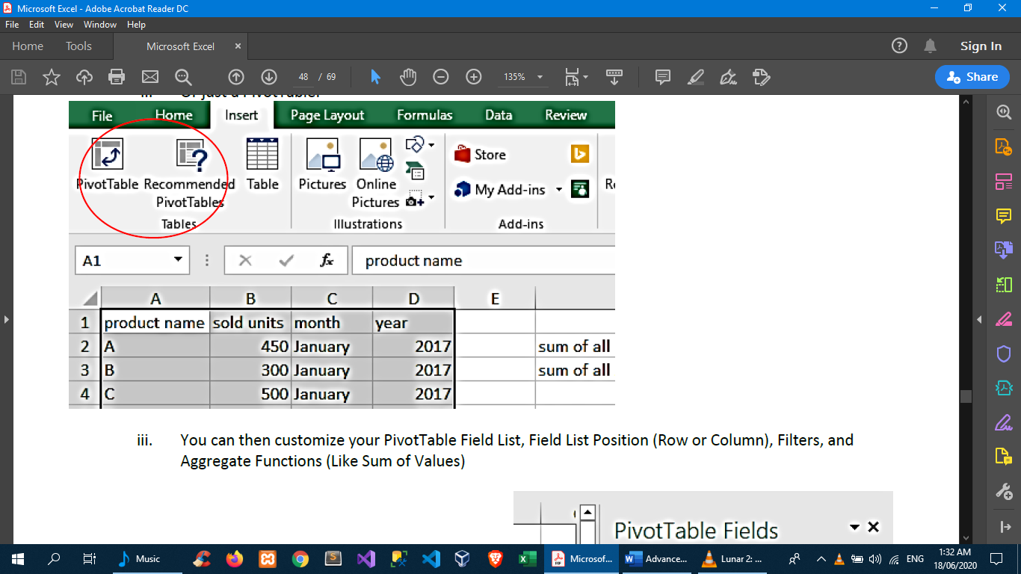

🡪You can then customize your PivotTable Field List, Field List Position (Row or Column), Filters, and Aggregate Functions (Like Sum of Values)

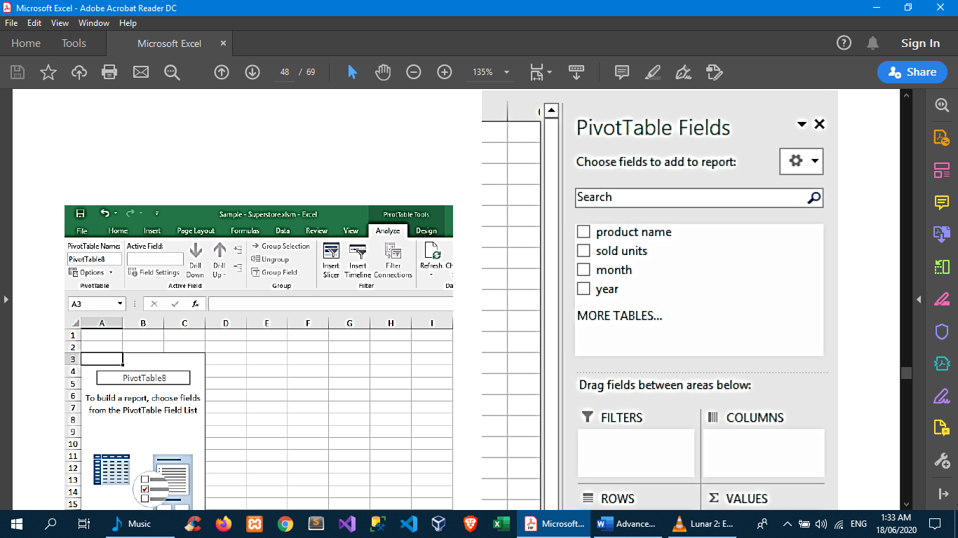

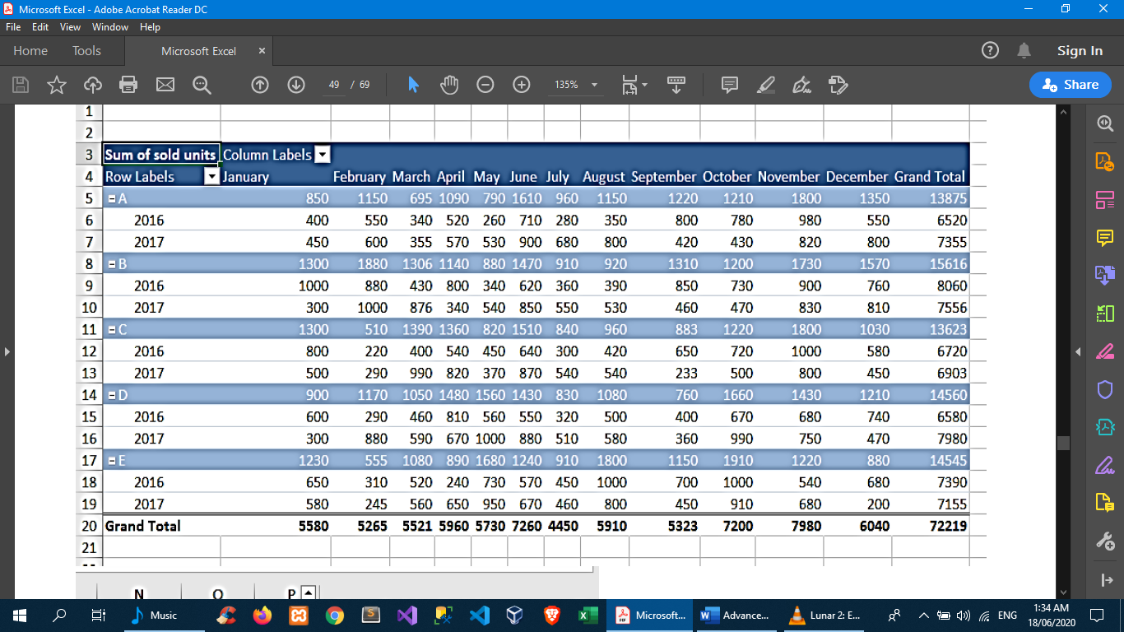

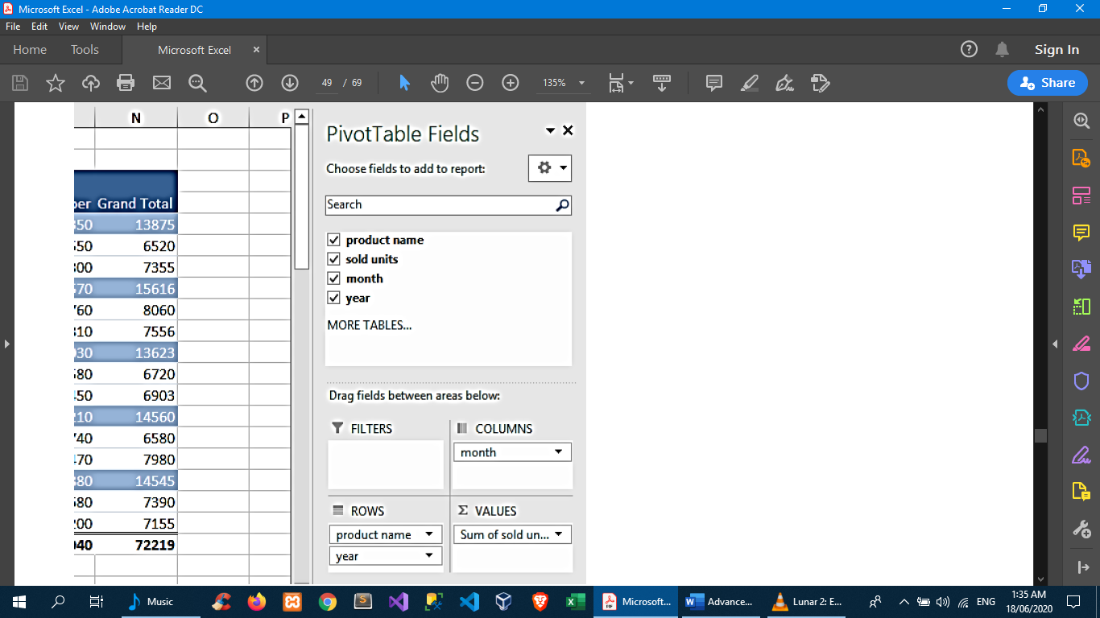

**Text Files**

Import a text file by connecting to it

You can import data from a text file into an existing worksheet.

1. Click the cell where you want to put the data from the text file.
2. On the Data tab, in the Get External Data group, click From Text.
3. In the Import Data dialog box, locate and double-click the text file that you want to import, and click Import.

Follow the instructions in the Text Import Wizard. Click Help button image on any page of the Text Import Wizard for more information about using the wizard. When you are done with the steps in the wizard, click Finish to complete the import operation.

1. In the Import Data dialog box, do the following:
   * Under Where do you want to put the data?, do one of the following:
     + To return the data to the location that you selected, click Existing worksheet.
     + To return the data to the upper-left corner of a new worksheet, click New worksheet.
   * Optionally, click Properties to set refresh, formatting, and layout options for the imported data.

Click OK.

Excel puts the external data range in the location that you specify.

If Excel does not convert a column of data to the format that you want, you can convert the data after you import it. For more information, see Convert numbers stored as text to numbers and Convert dates stored as text to dates.

Export data to a text file by saving it

You can convert an Excel worksheet to a text file by using the Save As command.

1. Go to File > Save As.
2. The Save As dialog box appears.
3. In the Save as type box, choose the text file format for the worksheet.
   * For example, click Text (Tab delimited) or CSV (Comma delimited).
4. Browse to the location where you want to save the new text file, and then click Save.
5. A dialog box appears, reminding you that only the current worksheet will be saved to the new file. If you are certain that the current worksheet is the one that you want to save as a text file, click OK. You can save other worksheets as separate text files by repeating this procedure for each worksheet.
6. A second dialog box appears, reminding you that your worksheet may contain features that are not supported by text file formats. If you are interested only in saving the worksheet data into the new text file, click Yes. If you are unsure and would like to know more about which Excel features are not supported by text file formats, click Help for more information.

REST Calls

Excel uses a table from the web

1. prepare website table source

ex. <https://www.x-rates.com/table/?from=PHP&amount=1>

1. in excel:

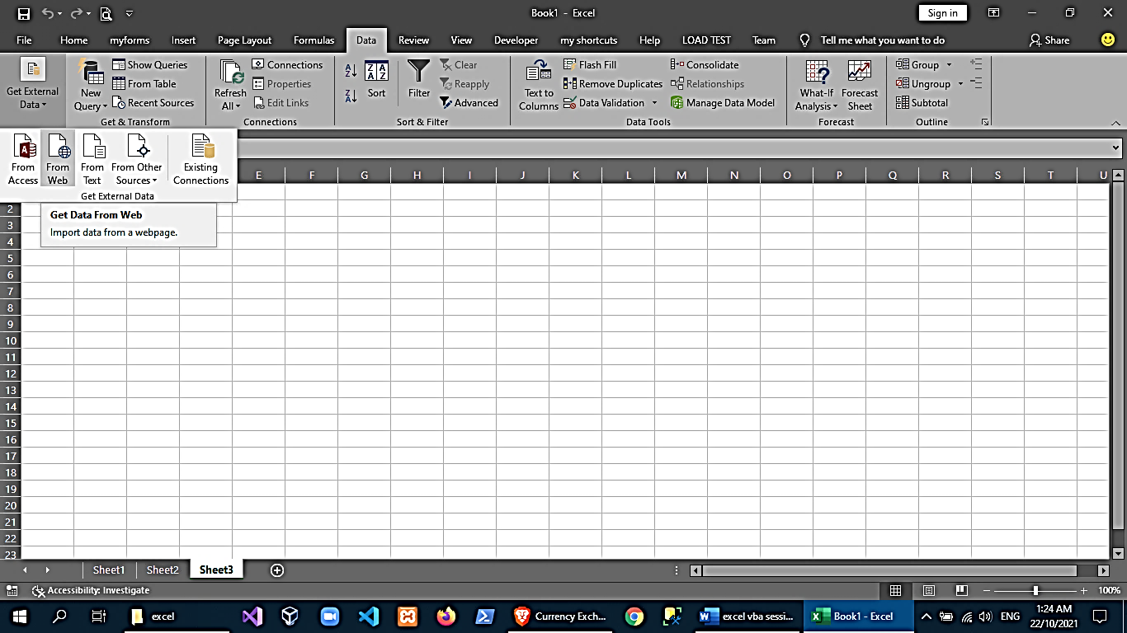

1. Enter the URL and select the table you want to import, then click the import button

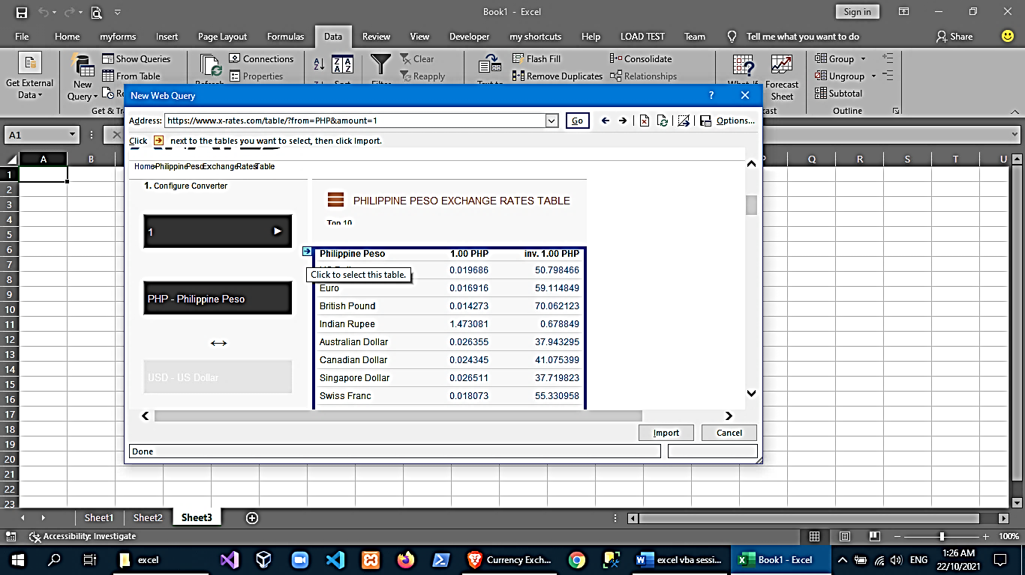

1. choose where to import data

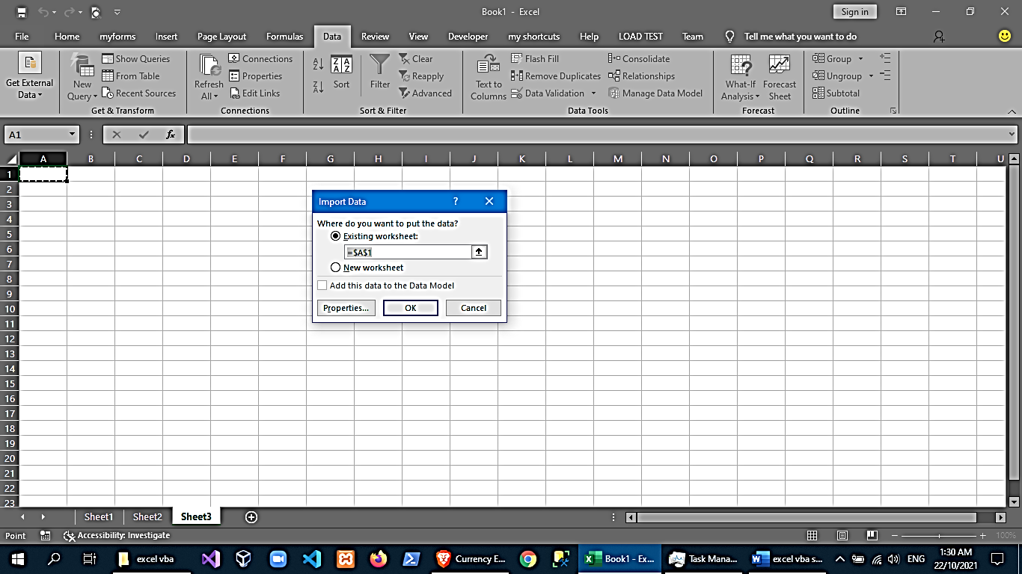

1. wait until data is imported

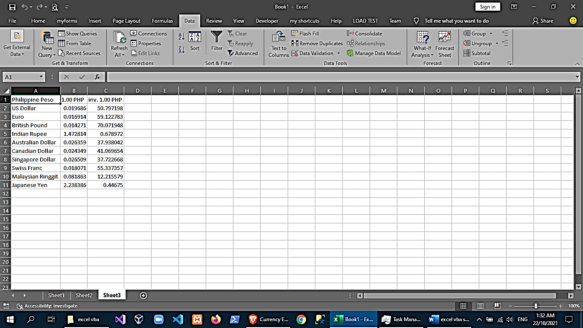

1. You can modify External Data Settings like the refresh interval

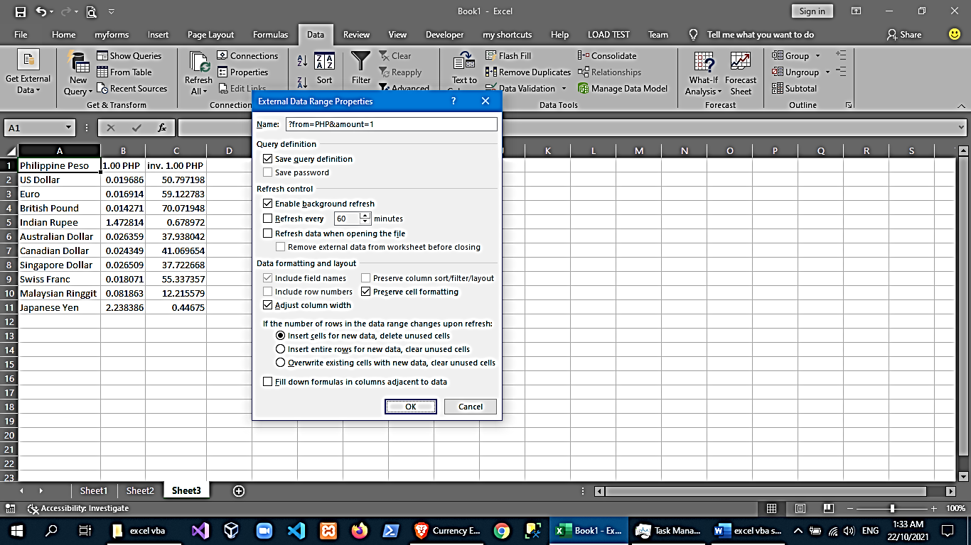

1. You can also connect directly using the same approach to a web api and fetch data

examples:

<https://public-apis.io/>

<https://newsapi.org/s/philippines-news-api>

<https://min-api.cryptocompare.com/data/histominute?fsym=BTC&tsym=USD&limit=288&aggregate=5>

1. In excel:

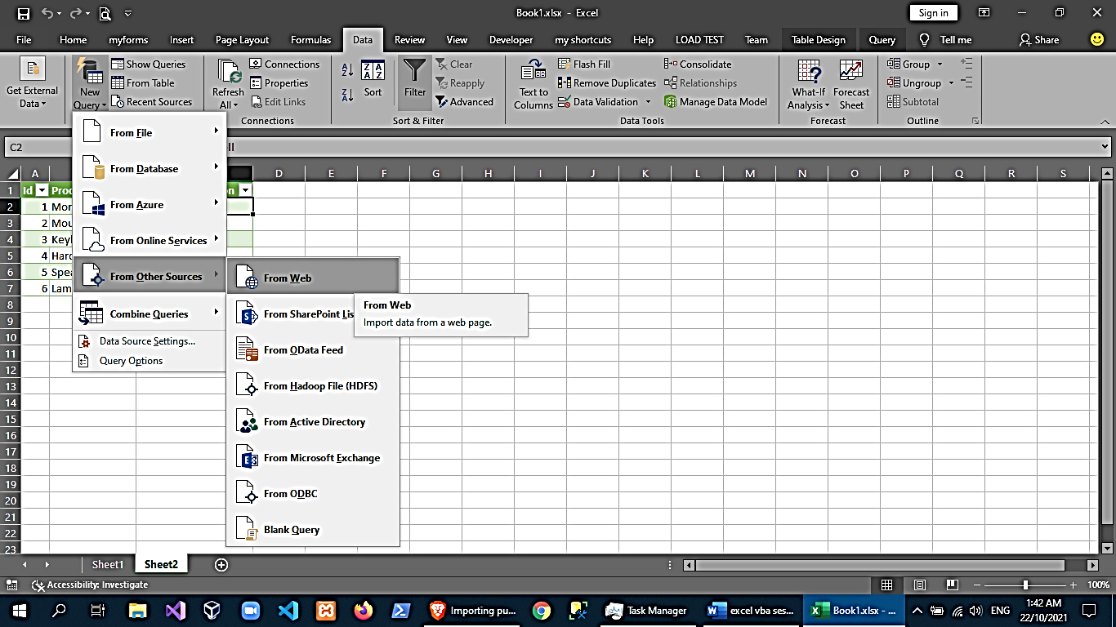

1. Enter the Web API URI

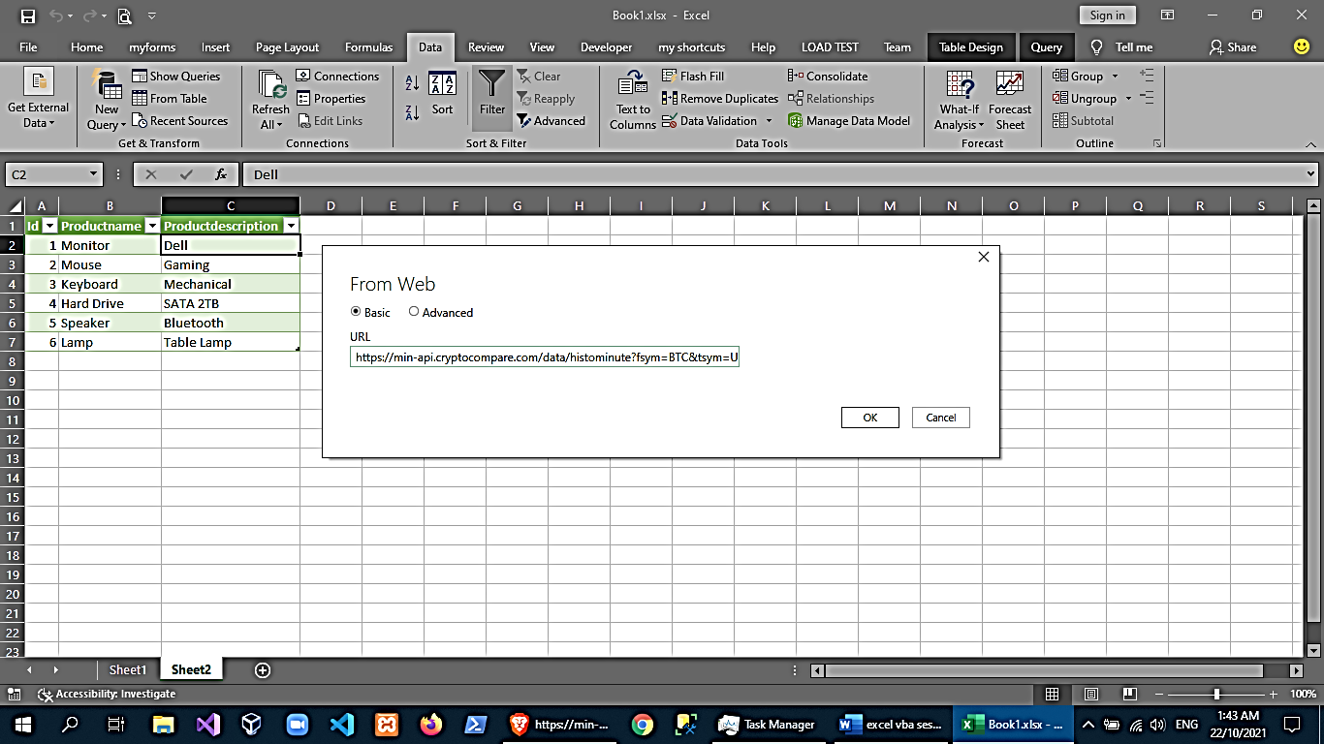

1. you can now try configuring the connection

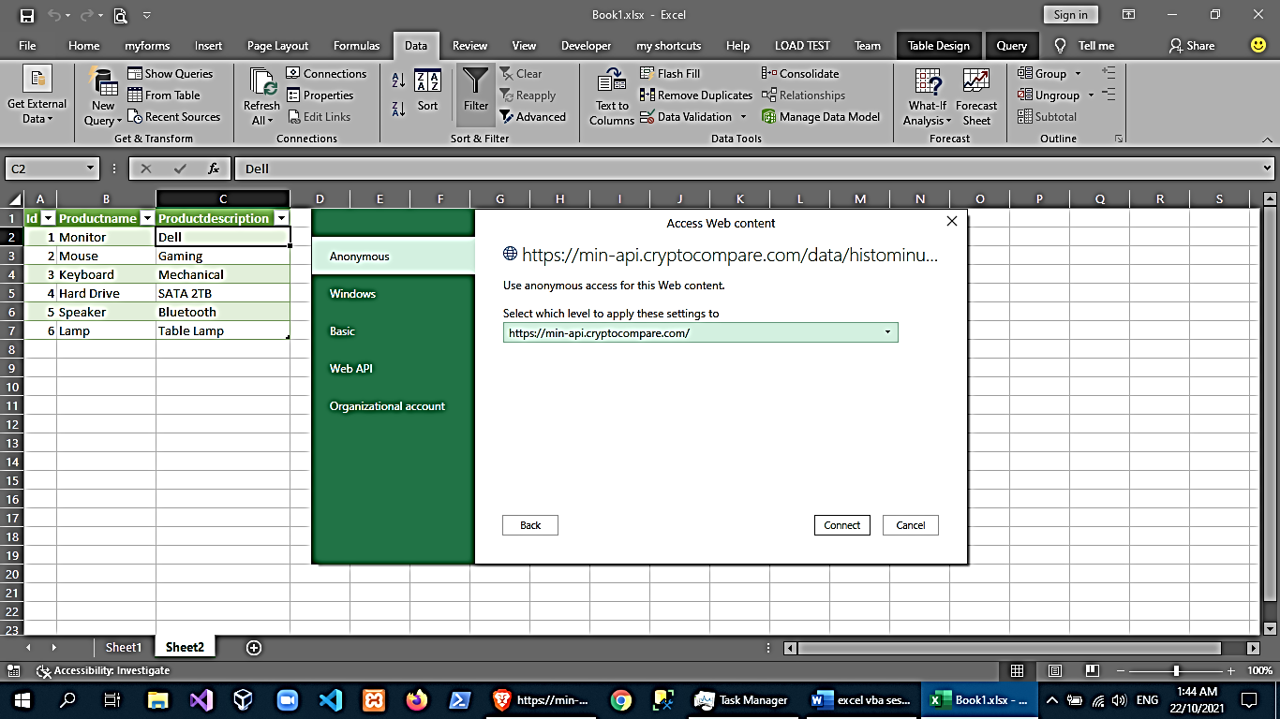

1. In the convert tab, click *Into Table*

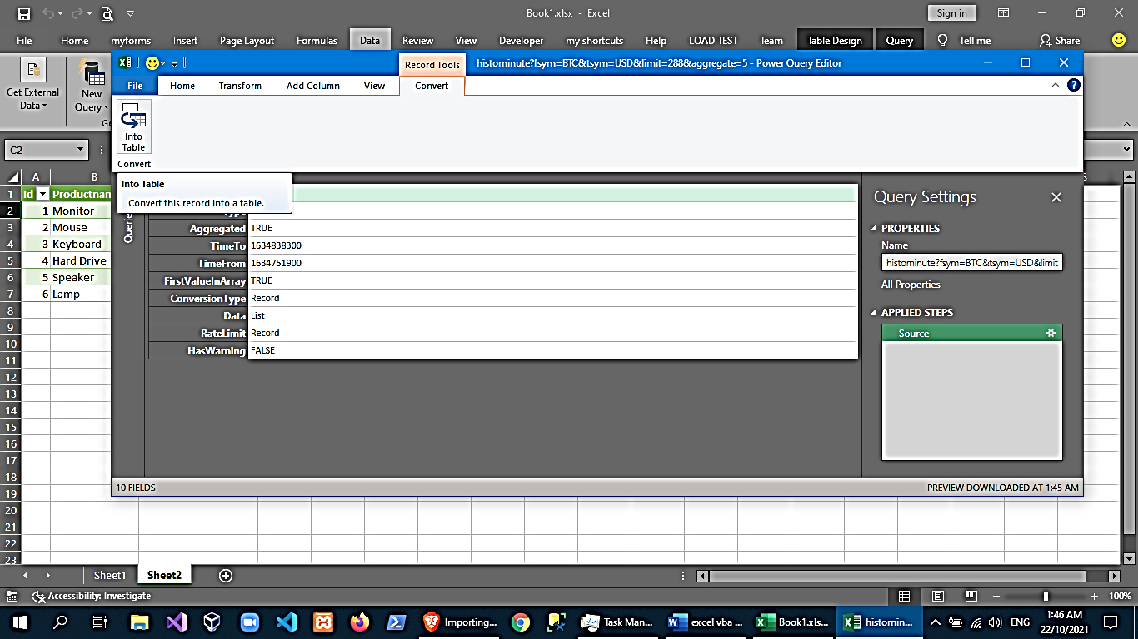

1. select value of Data🡪rclick Drill Down

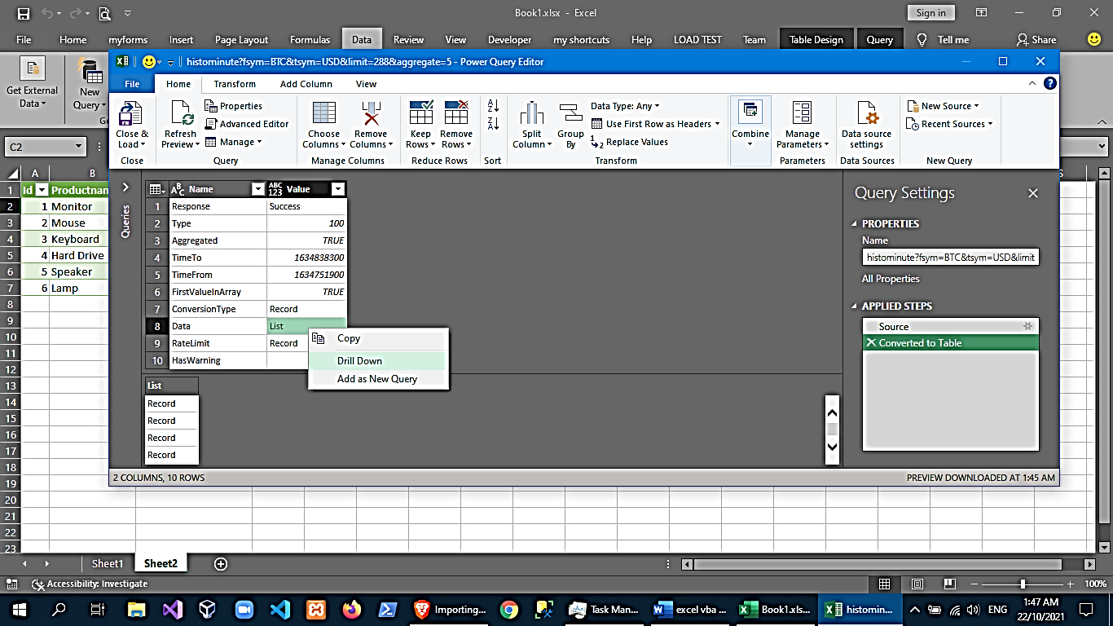

1. then on the Transform Tab🡪click *To Table*

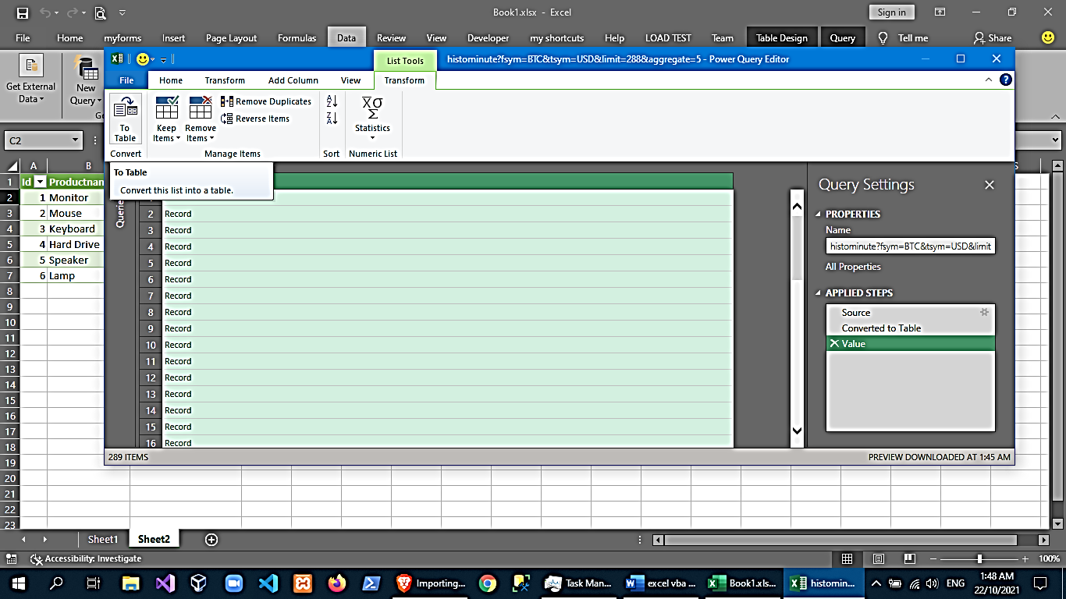

1. you may keep the default settings here and click ok

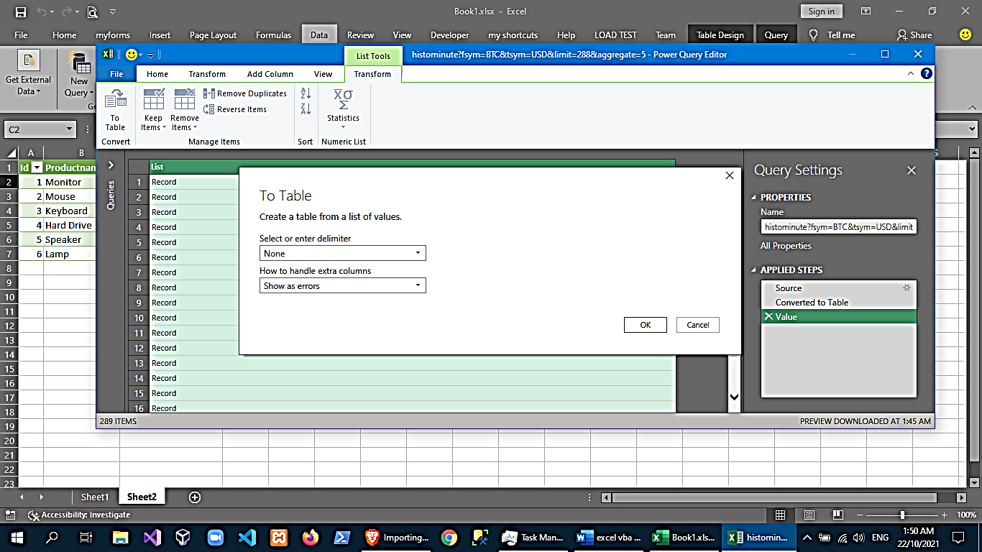

1. click the top-right corner (left & right arrow icon), then uncheck “use original column names”, finally click “close & load”

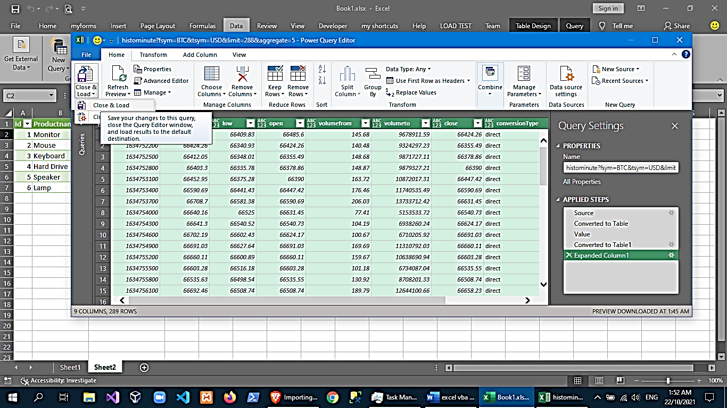

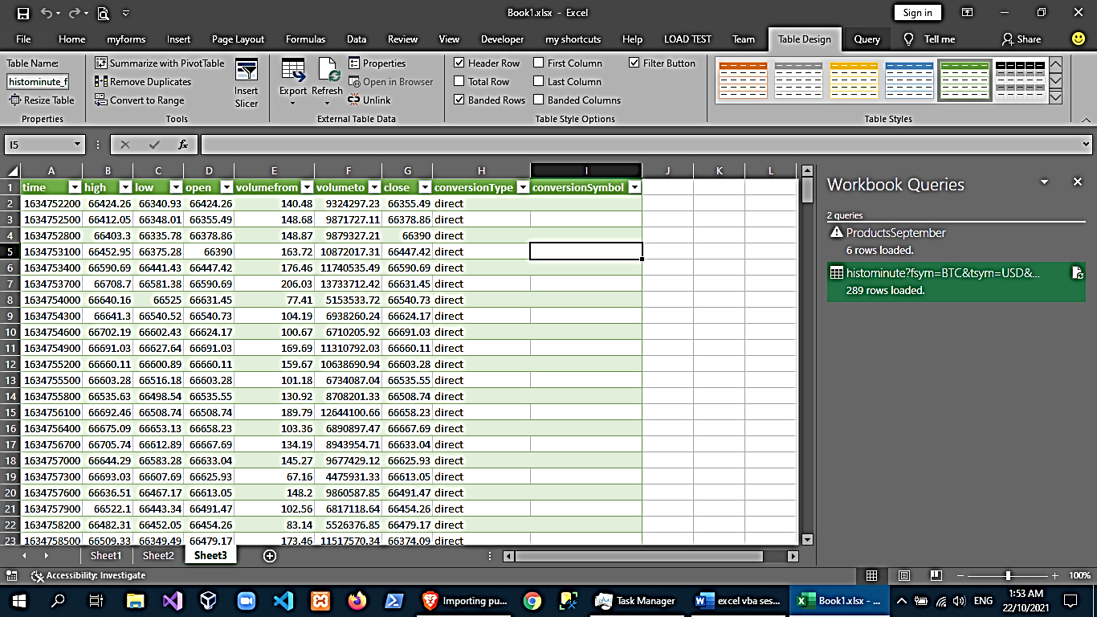

Though, for this Web API the time we retrieved is in a Unix timestamp. The next that we’re going to do is add a custom column and convert that to time and date format in Excel.

A quick Google Search would give us the formula

=((([time] /60)/60)/24)+DATE(1970,1,1)

1. To edit our query, go to Query>Edit or Data>Get Data> Launch Query Editor…

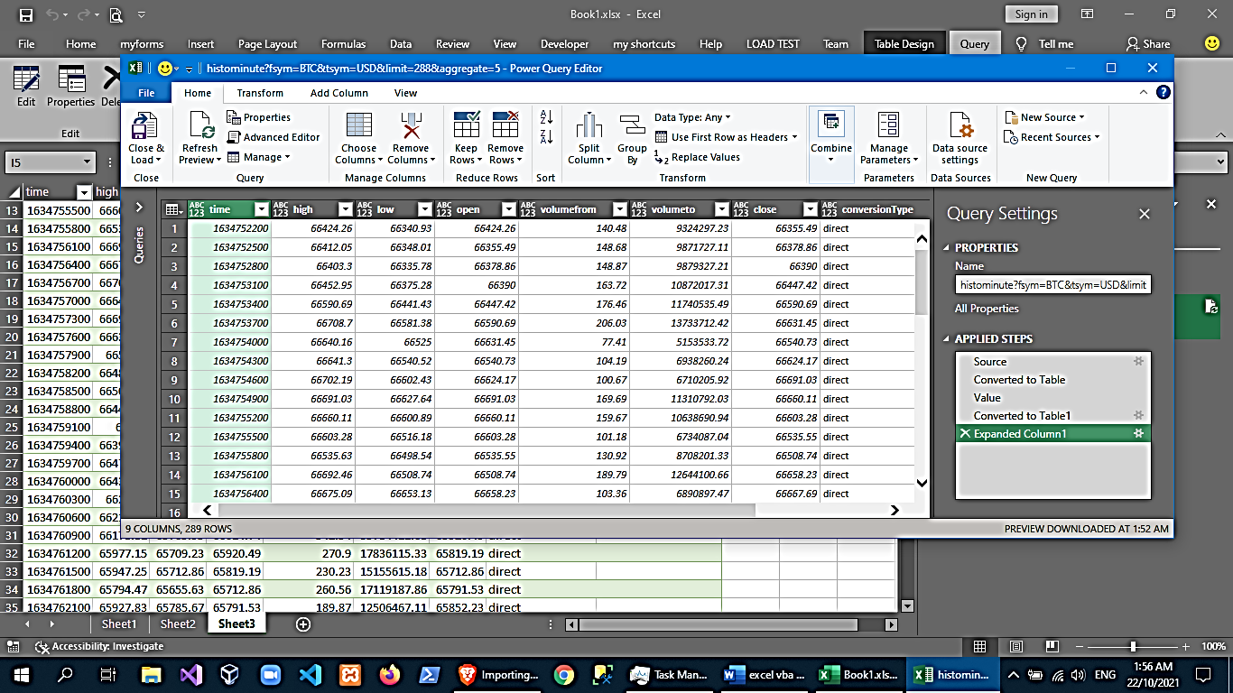

1. On the query editor select Add Column>Custom Column then put out formula. Note: The query editor uses a different language call Power Query formula so will replace our formula with its equivalent.

=((([time]/60)/60)/24) + Number.From(#date(1970,1,1))

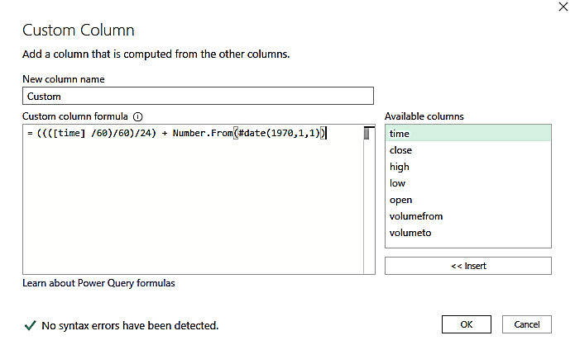

1. Now we have a new column. Let’s convert the column to Date/Time format. To do that, select custom column and on the transform tab and select date/time on the Data Type drop down.

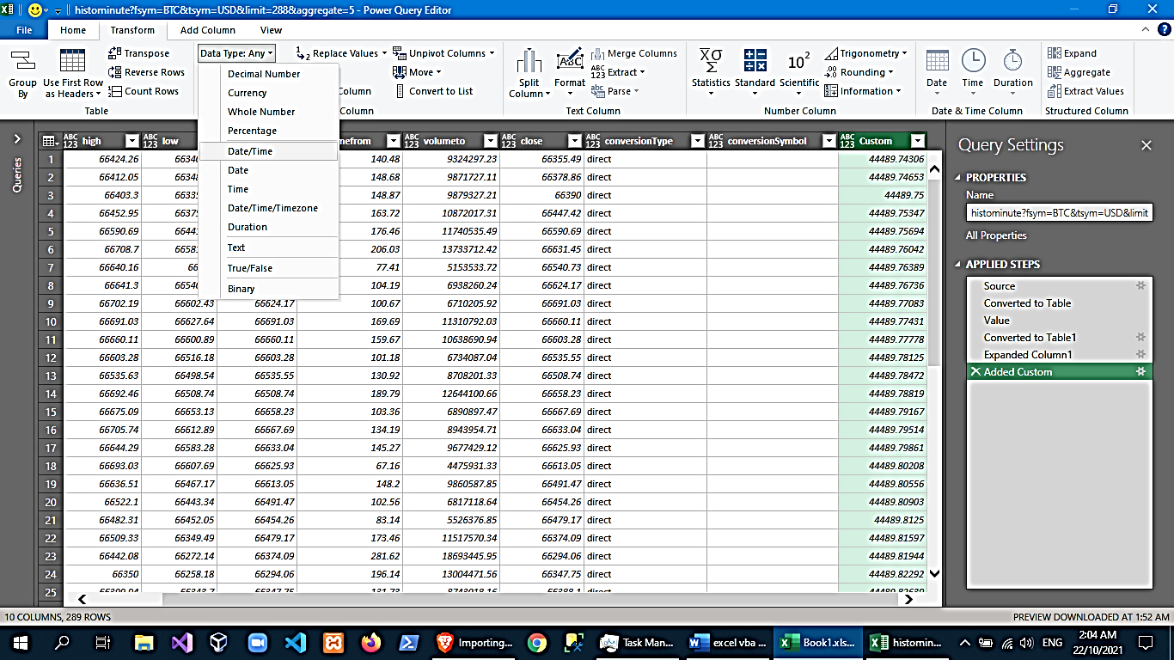

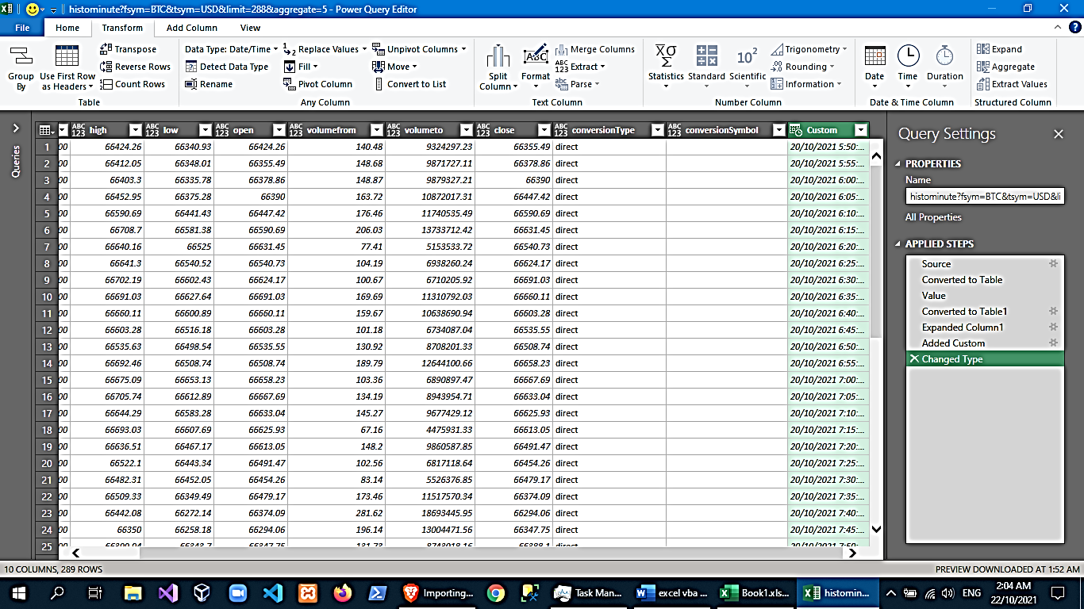

1. Now we’ll replace the original time column. Move the custom column to the Beginning and remove the time column.

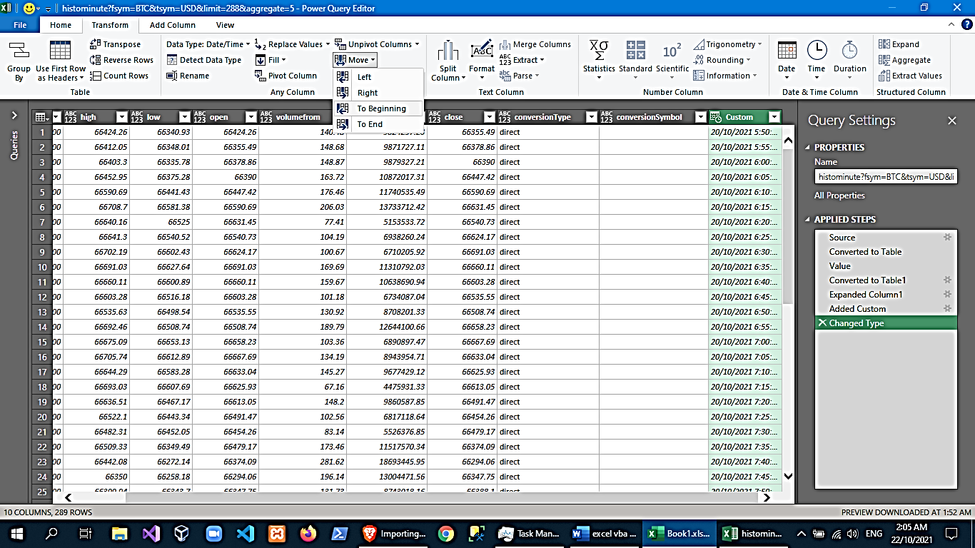

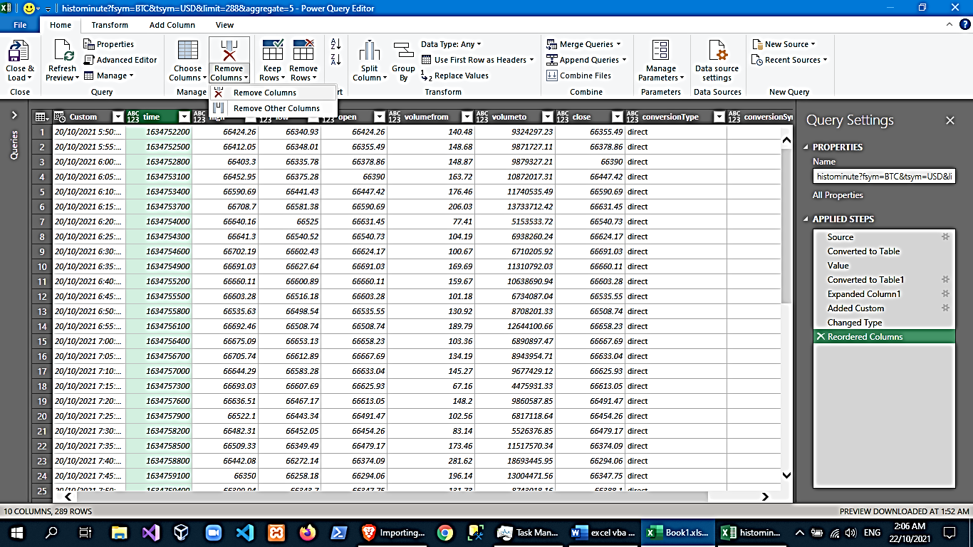

1. Then rename the custom column to time and go to Home>Close & Load.

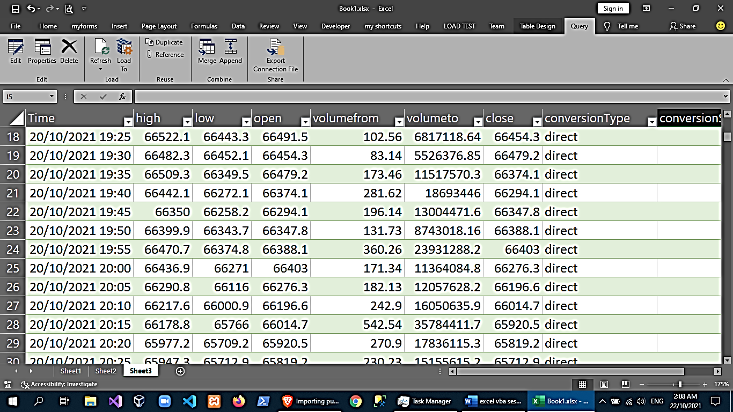

Database Connection

**Connect to a Microsoft SQL Server**

1. Prepare MS SQL Server Host
2. In excel:

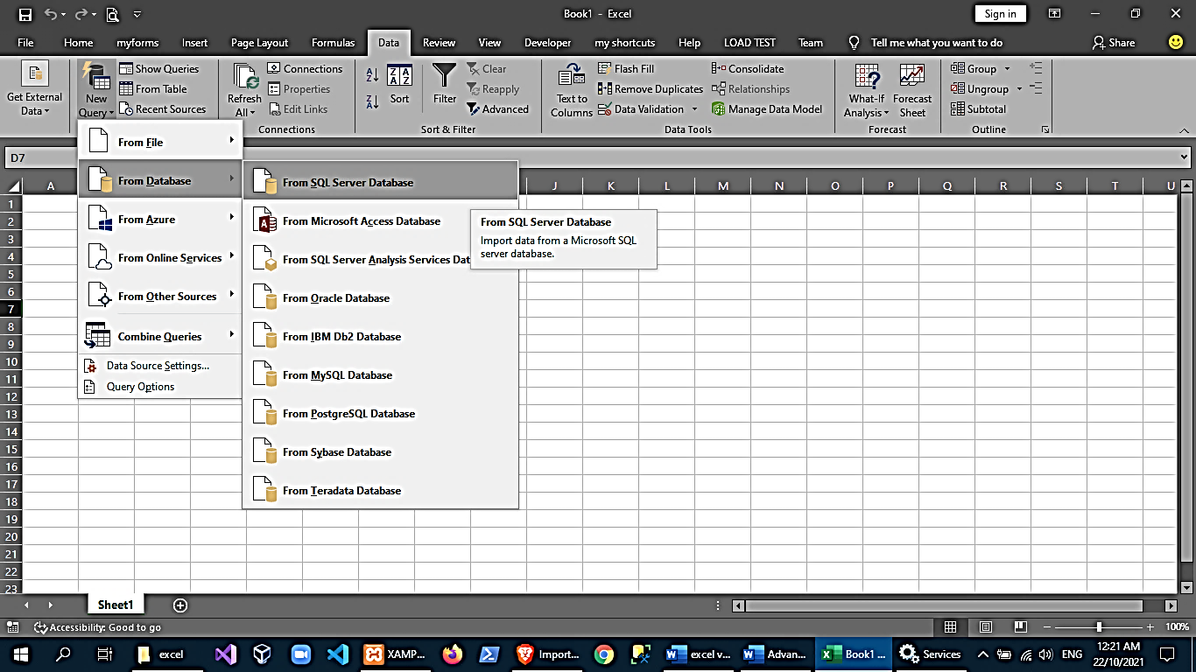

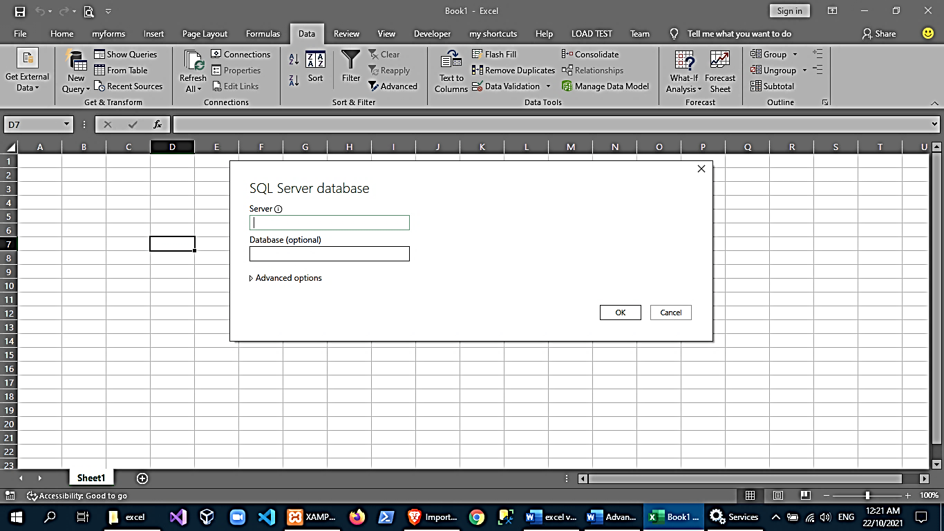 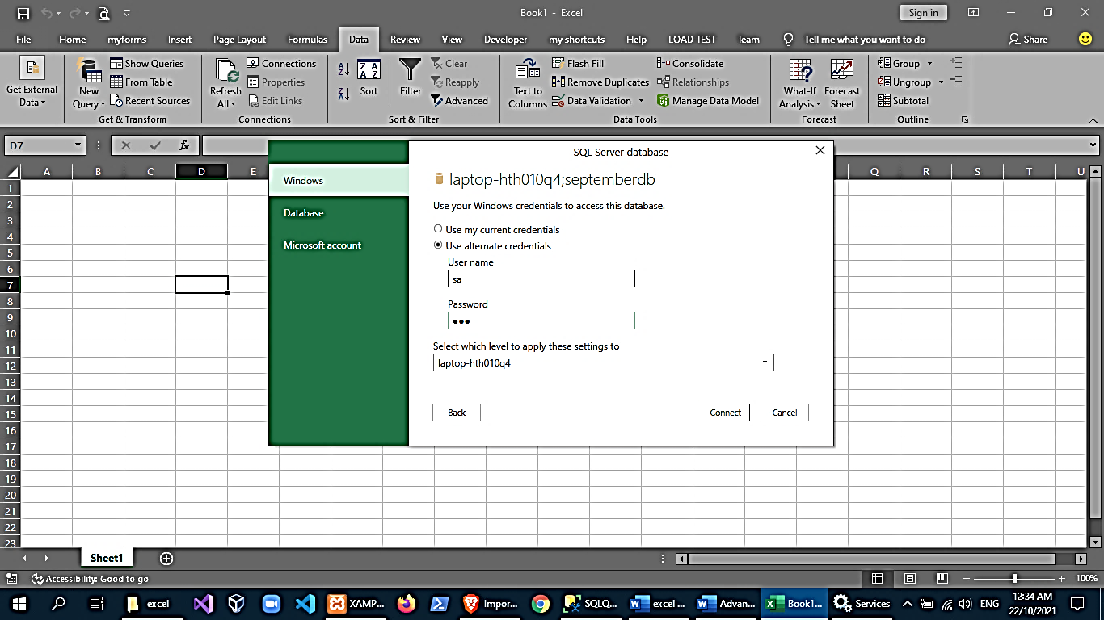

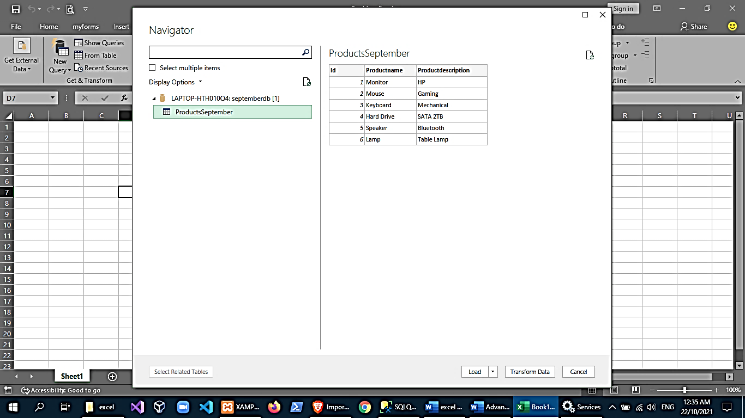

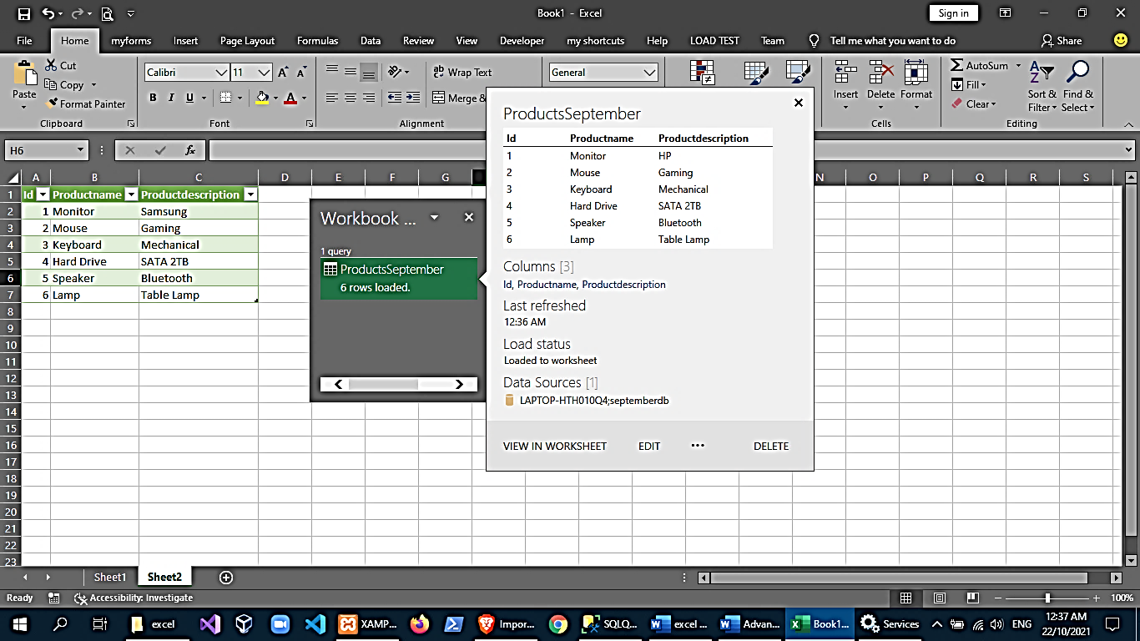

Query Tab🡪 edit

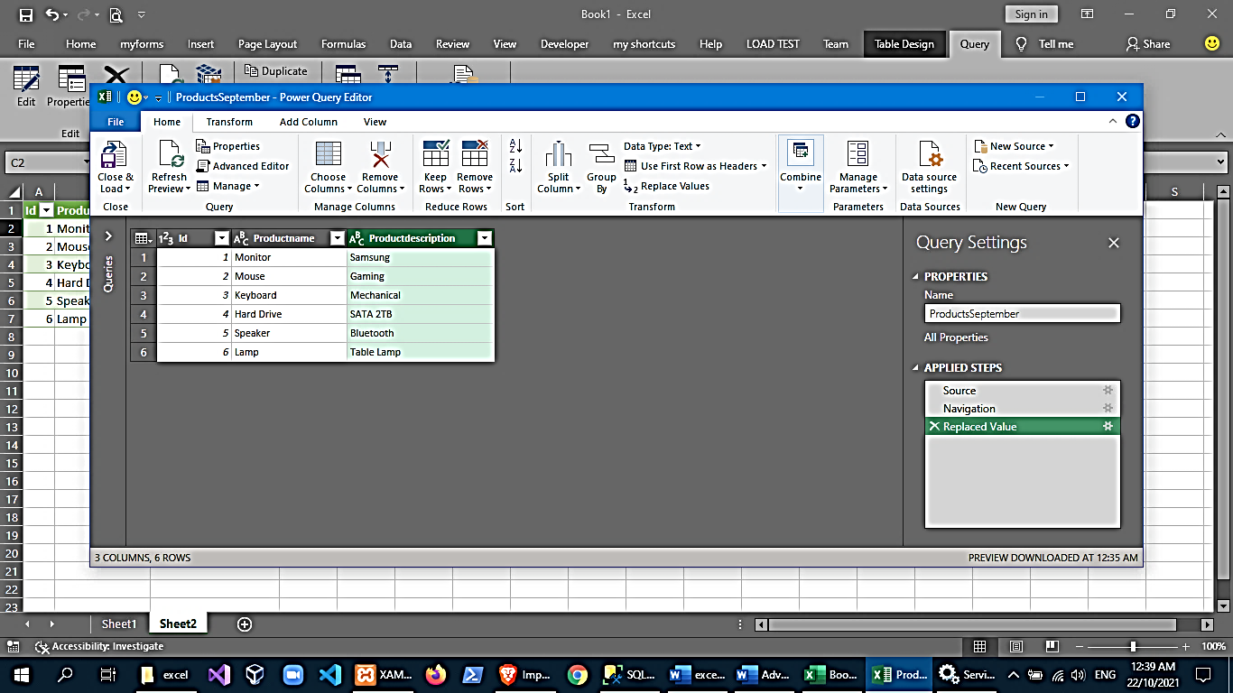

**Using SQL Server Import and Export Wizard**

Export data from MS SQL Server to MS Excel File

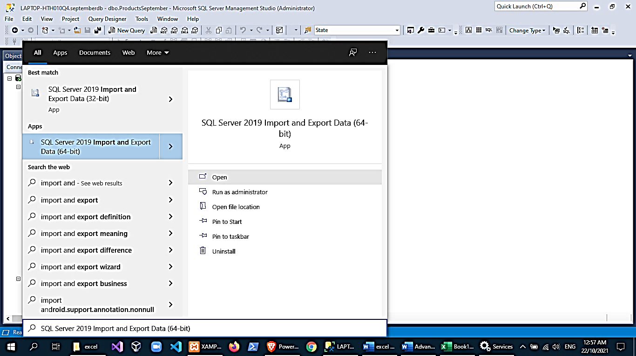 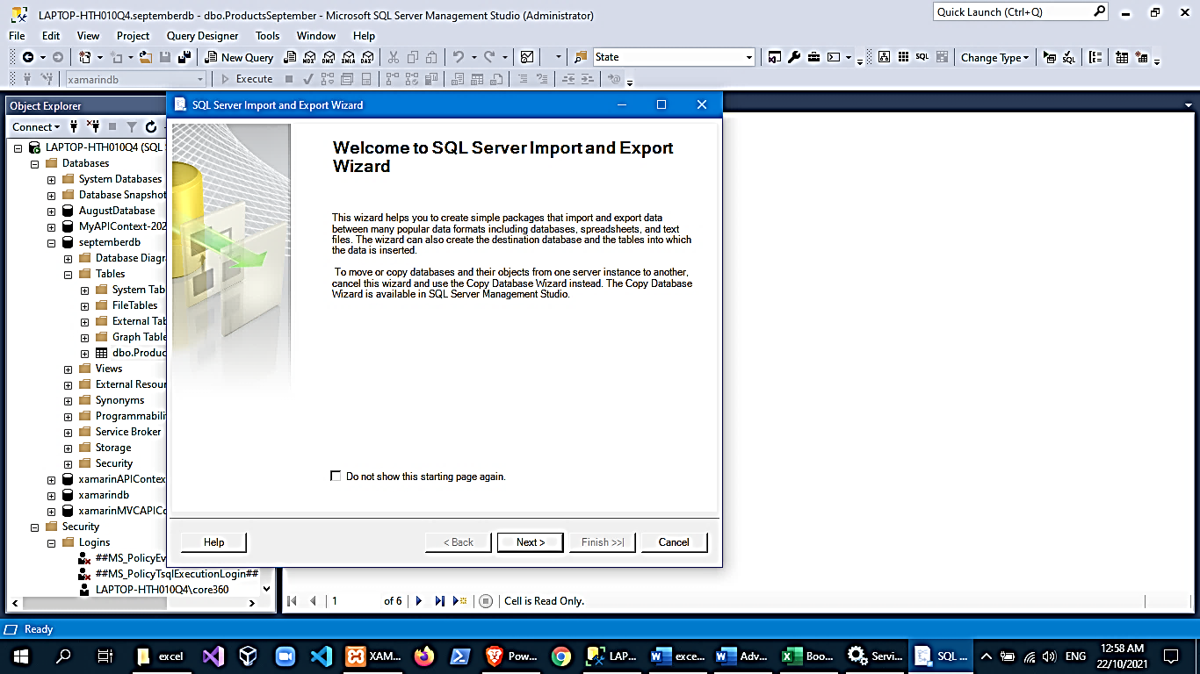

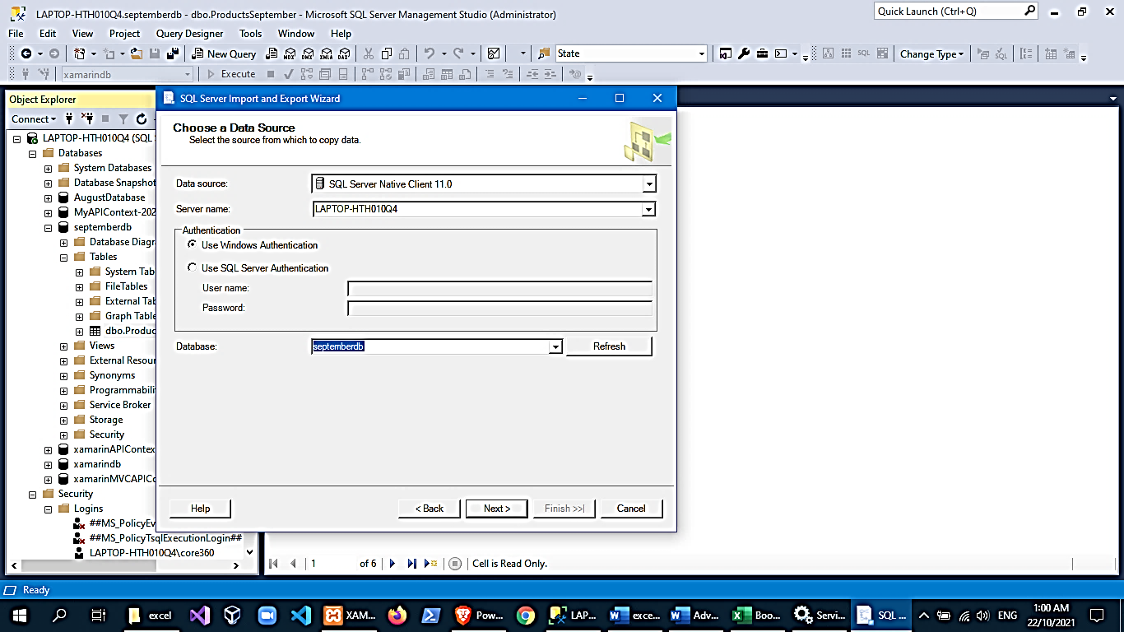 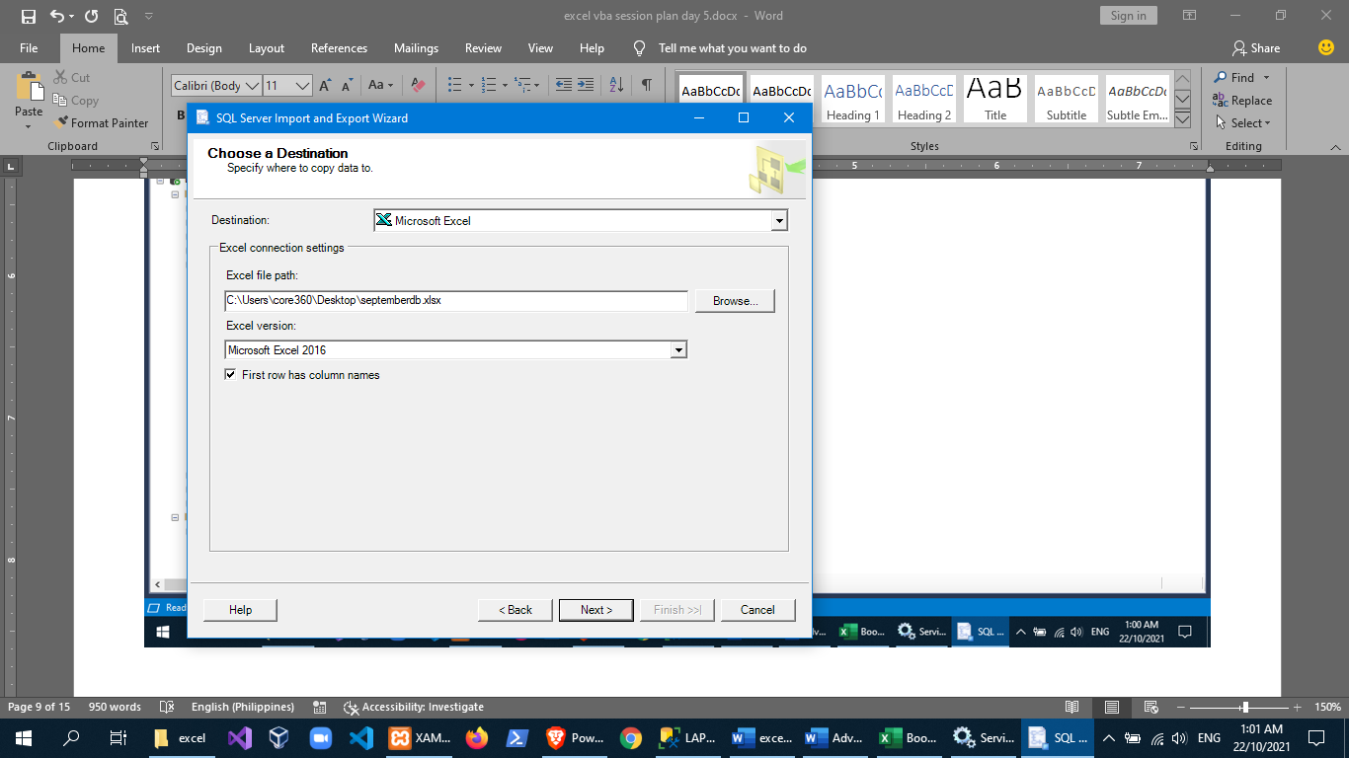

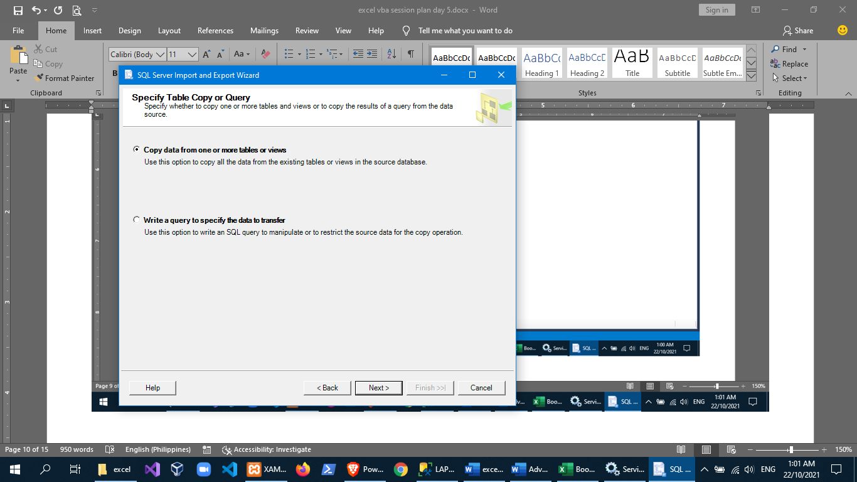 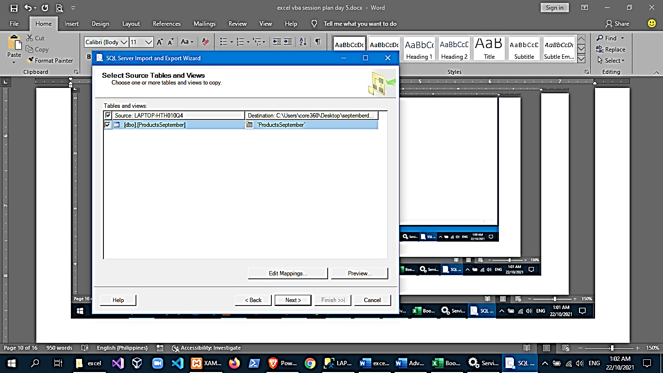

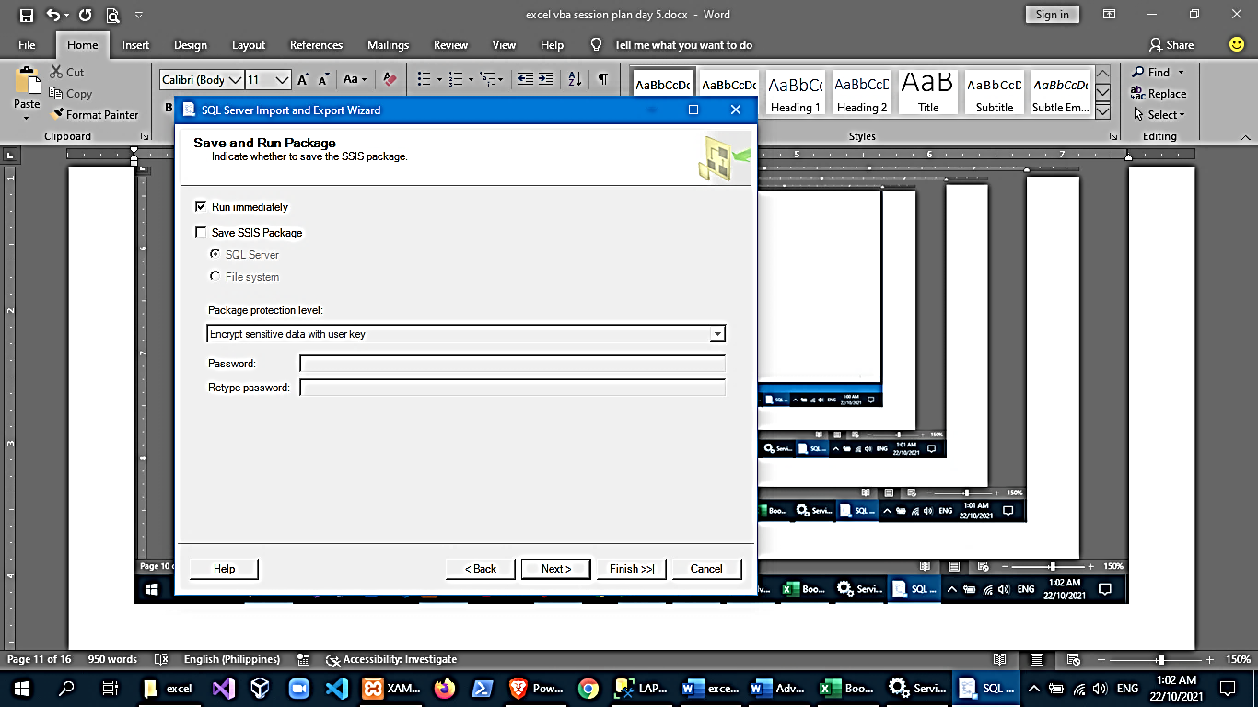 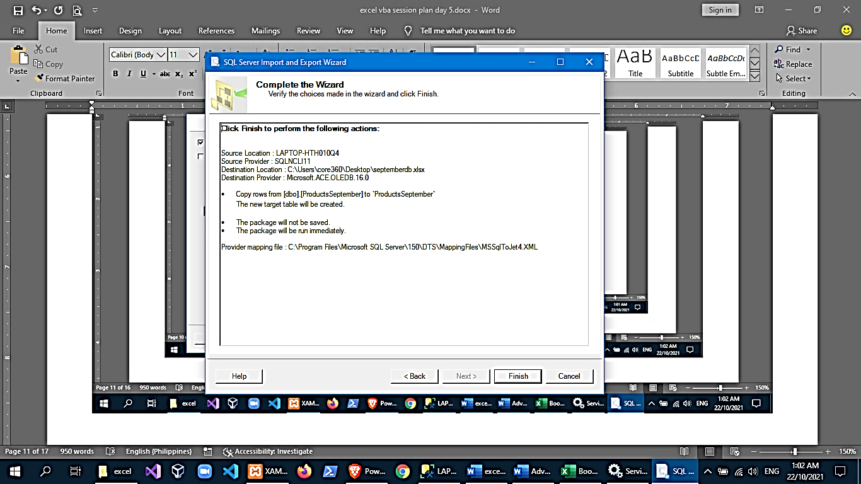

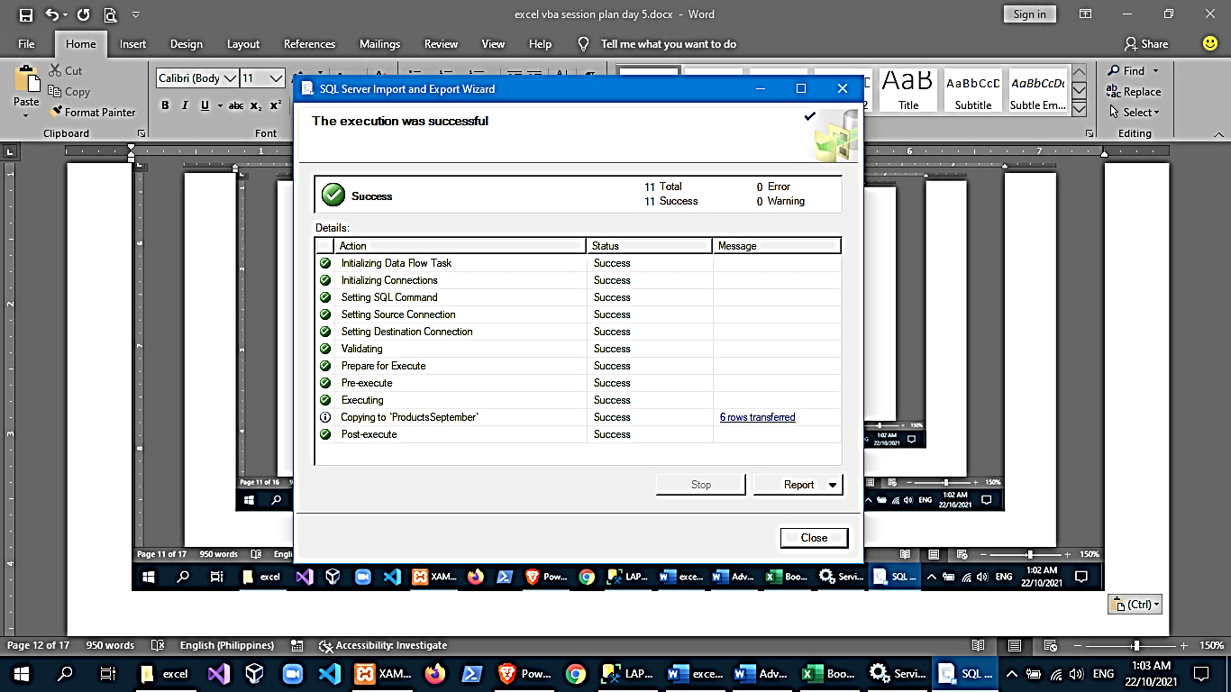 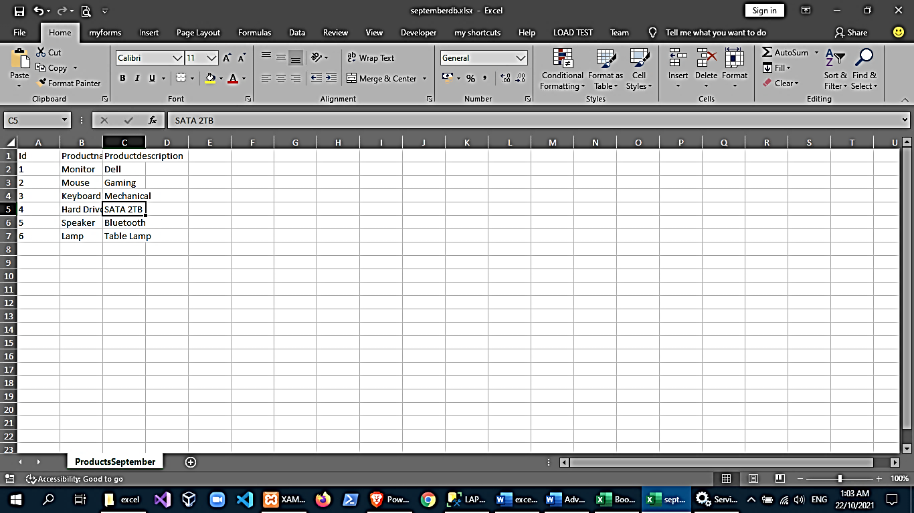

Recursive

**What is a Recursive Function?**

A recursive function calls itself as part of its program flow.

Function CalcSomething(…) as Long

…

X = CalcSomething(…)

…

End Function

**Advantages/Disadvantages of Recursion**

Advantages of recursion

1. The code may be easier to write.

2. To solve such problems which are naturally recursive such as tower of Hanoi.

3. Reduce unnecessary calling of function.

4. Extremely useful when applying the same solution.

5. Recursion reduce the length of code.

6. It is very useful in solving the data structure problem.

7. Stacks evolutions and infix, prefix, postfix evaluations etc.

Disadvantages of recursion

1. Recursive functions are generally slower than non-recursive function.

2. It may require a lot of memory space to hold intermediate results on the system stacks.

3. Hard to analyze or understand the code.

4. It is not more efficient in terms of space and time complexity.

5. The computer may run out of memory if the recursive calls are not properly checked.

Example:

***Conceptualizing a recursive algorithm***

Let’s consider the following simple task: find a given country name within a list of countries of the world.

We assume that we have the list of countries sorted alphabetically.

We need to write an efficient VBA function to return True if the given country name is found in the list.

The list will be conveniently copied from an Excel Worksheet table into an array. You may recall that processing arrays is way faster that running over a range of cells.

The first approach that may come to mind, is running a loop over the array, matching each array member to our candidate country until a match, or until the loop ends.

I will now suggest a little different approach:

If we split the list of countries right in the middle, we can quickly judge whether our target country is expected to be found in the first half, or in the second half of the list (remember, our list is sorted!).

Having determined the target half, we have exactly the same task at hand: find our country in a list of countries, only our list is now HALF its original length. We have broken our broomstick!

Not only that, but since we are tasking our function to do exactly that: finding a country within a list of countries, we can call it again – to process a shorter list of countries this time!

We can now plot our function algorithm to be:

1. Split the received list of countries in half
2. If our candidate country matches the mid-list country – we found a match – exit the function
3. If the list length is 1 – our country is not here – exit the function
4. Identify the half expected to host our candidate country: left half or right half of the split
5. Go to step 1 with the selected half of the list

The power of our approach is derived by the exponential pace in which we reduce the size of our countries list, as we cut its size in half on each iteration. How many function calls are needed to cover a list of 200 countries?

First call – 200 countries

Second call – 100 countries

Third call – 50 countries

Fourth call – 25 countries

Fifth call – 13 countries

Sixth call – 7 countries

Sevenths call – 4 countries

Eights call – 2 countries

Ninths call – 1 country

Less than 10 function calls (and processing) are needed to crunch a list of 200 countries!

12 runs will cover more than 4,000 items (4,096, to be precise). It’s about the power of two (2^12 = 4,096).

This same approach is used in a bubble-sorting algorithm, which is a common assignment given to students to practice recursive functions: Split the list of items and sort two items only: the “left” against the “right”.

***Implementing a recursive function in Excel VBA***

To implement our country finding function in Excel VBA, let’s first prepare a test function to ask the user for a country to find, call our recursive function and deliver a proper message to the user:

Sub GetCountry()

Dim strCountry As String

Dim arrCountries() As Variant

Dim strMessage As String

arrCountries = ThisWorkbook.Sheets("Countries").Range("CountriesTable[#Data]").Value

strCountry = InputBox("What is your country?", "Country Selection")

If (strCountry <> vbNullString) Then

If (DoesCountryExists(arrCountries, strCountry)) Then

strMessage = "You are from a real country!"

Else

strMessage = "You are from another planet I don't know"

End If

Else

strMessage = "Don't know what to do with an empty country..."

End If

MsgBox strMessage, vbOKOnly + vbInformation, "Country Search Results"

End Sub

Now we are ready to implement our recursive function, reflecting the algorithm we outlined above.

The act of cutting the list (array) in half is achieved by way of bounding half of the array within a starting index and an ending index.

Function DoesCountryExists(ByRef arrCountries() As Variant, strCountry As String, _

Optional iFrom As Long = 0, Optional iTo As Long = 0) As Boolean

'Returns True if strCountry is found in arrCountries.

Dim iMid As Long

If (iFrom + iTo) = 0 Then

iFrom = LBound(arrCountries, 1)

iTo = UBound(arrCountries, 1)

End If

If (iFrom >= iTo) Then Exit Function

iMid = Int((iTo - iFrom) / 2 + iFrom)

If (arrCountries(iMid, 1) = strCountry) Then

DoesCountryExists = True

Exit Function

End If

If (arrCountries(iMid, 1) > strCountry) Then

DoesCountryExists = DoesCountryExists(arrCountries, strCountry, iFrom, iMid - 1)

Else

DoesCountryExists = DoesCountryExists(arrCountries, strCountry, iMid + 1, iTo)

End If

End Function

Other advanced topics like data validation

1. Data Tables

Provides a what-if analysis for a computation by providing different answers using different values on a formula.

🡪prepare data

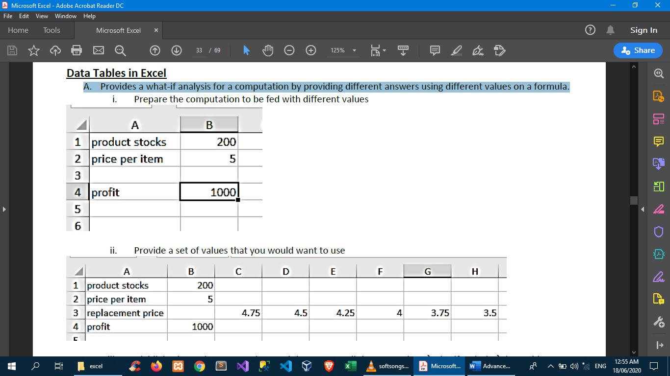

🡪provide values that you would want to test



🡪Highlight the replacement values and the answer cell then go to data→whatifanalysis→data table

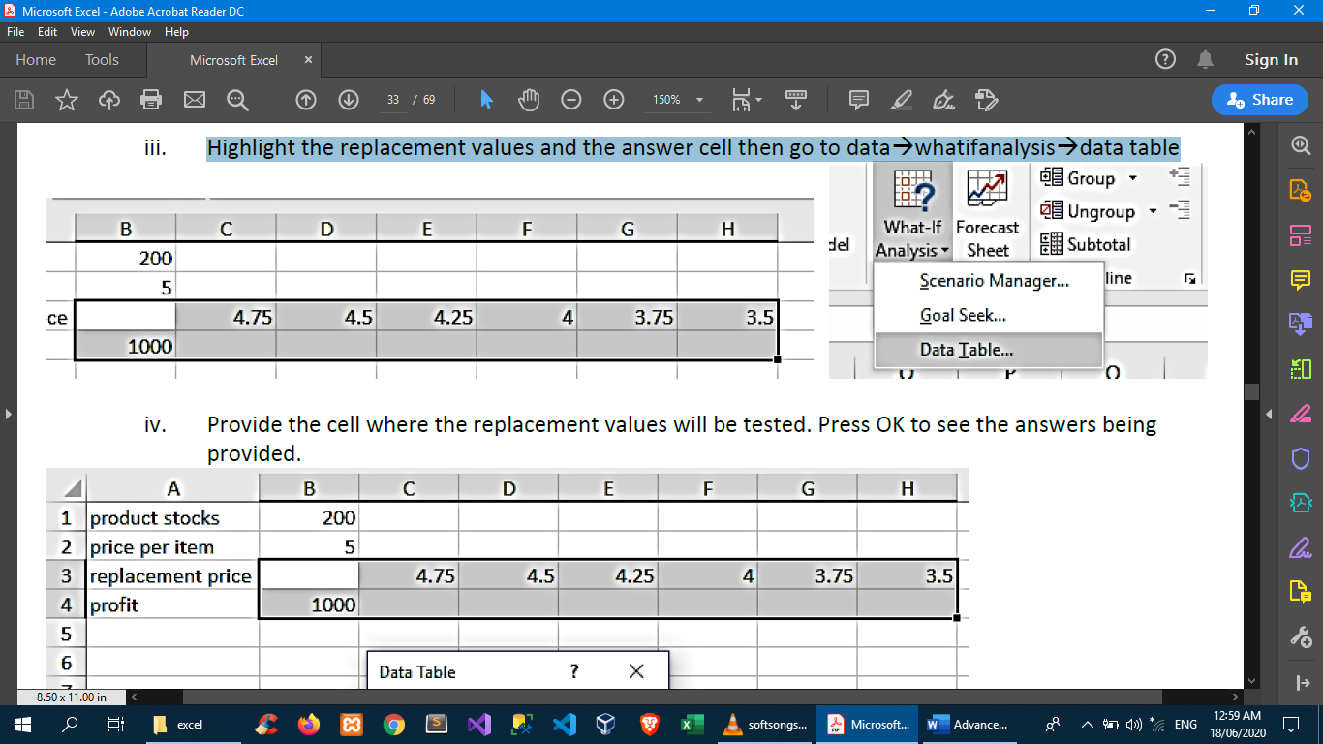

🡪Provide the cell where the replacement values will be tested. Press OK to see the answers being provided.

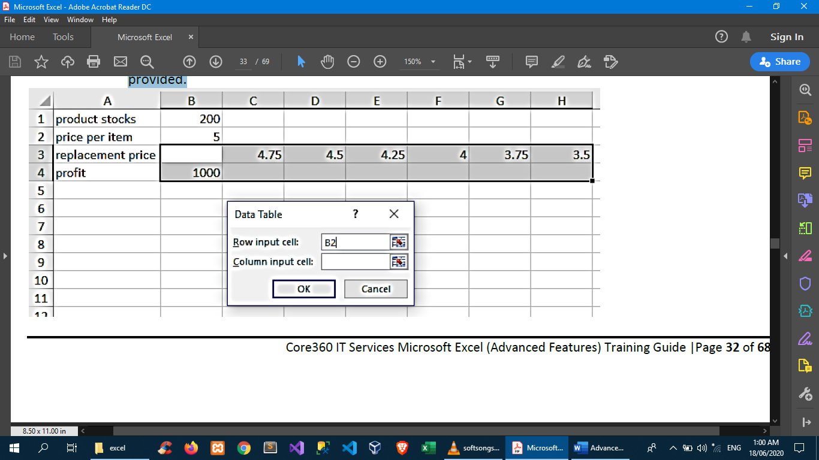

🡪sample output

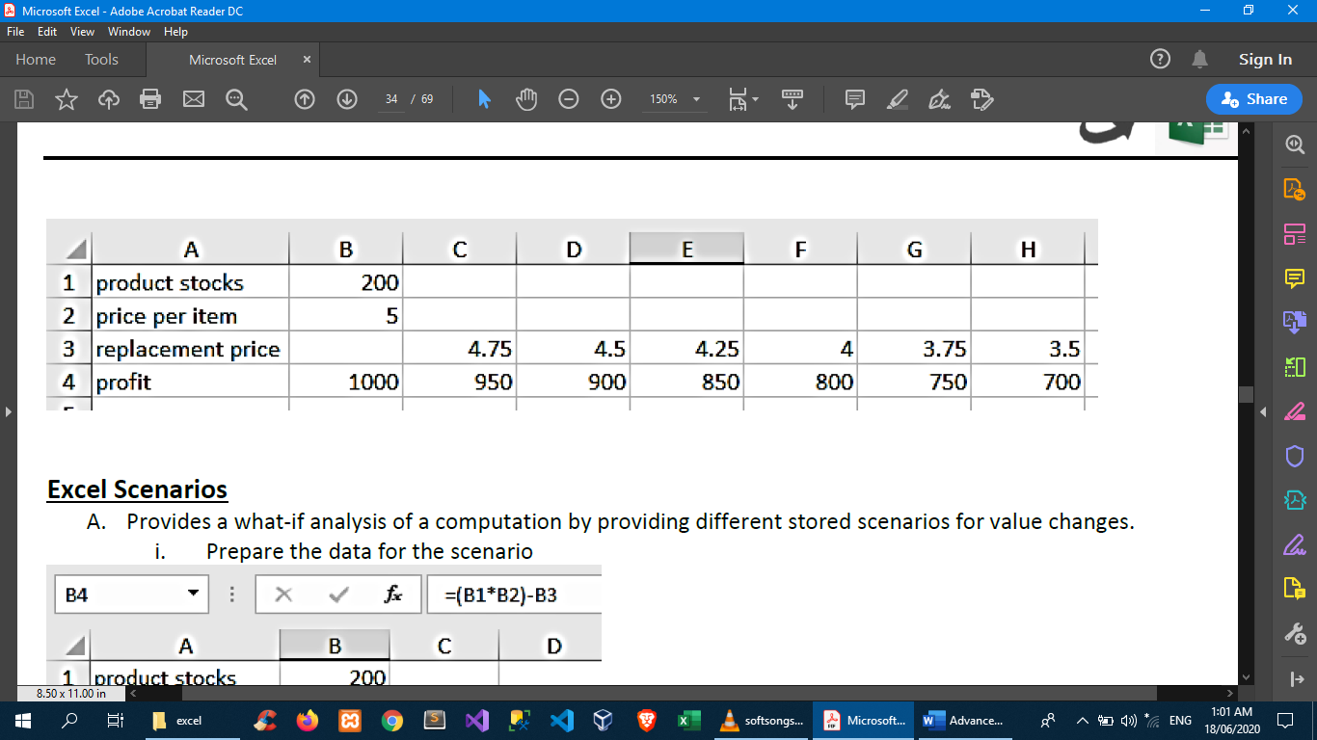

1. Excel Scenarios

Provides a what-if analysis of a computation by providing different stored scenarios for value changes.

🡪prepare data for the scenario

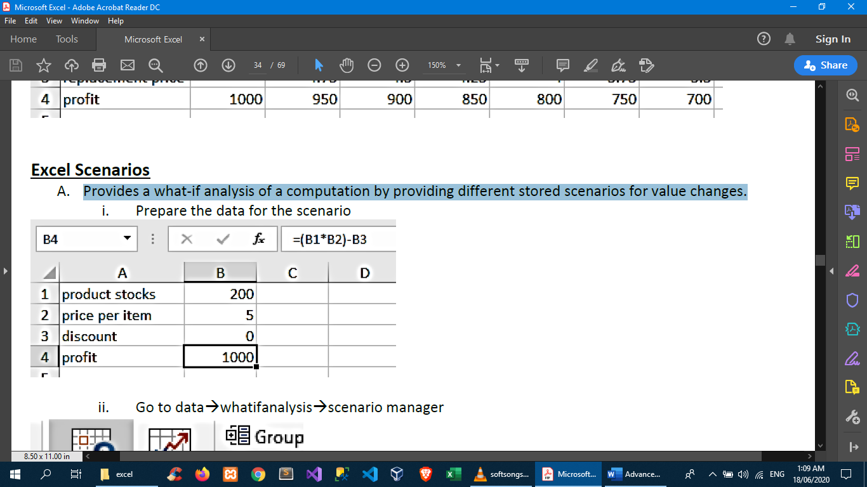

🡪data🡪whatifanalysis🡪scenario manager

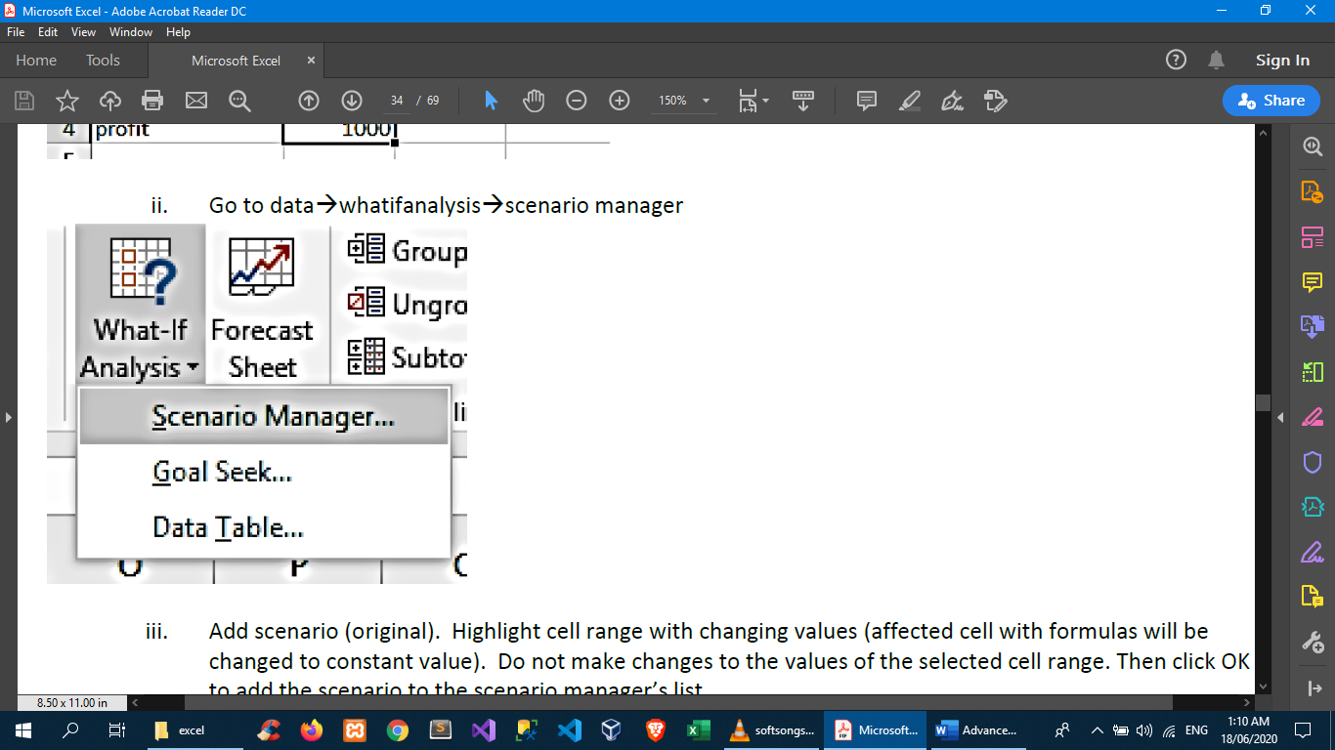

🡪Add scenario (original). Highlight cell range with changing values (affected cell with formulas will be changed to constant value). Do not make changes to the values of the selected cell range. Then click OK to add the scenario to the scenario manager’s list.

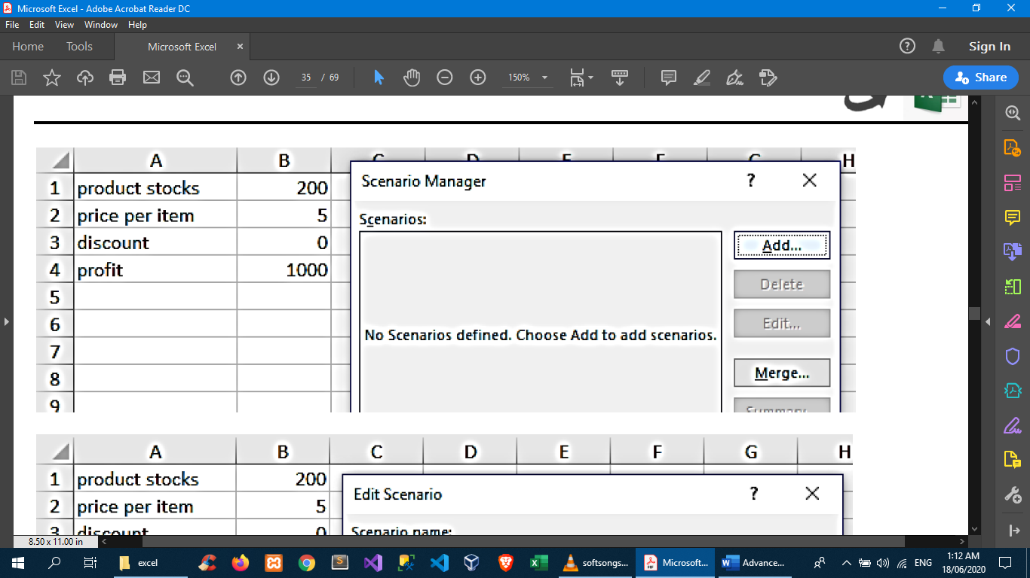

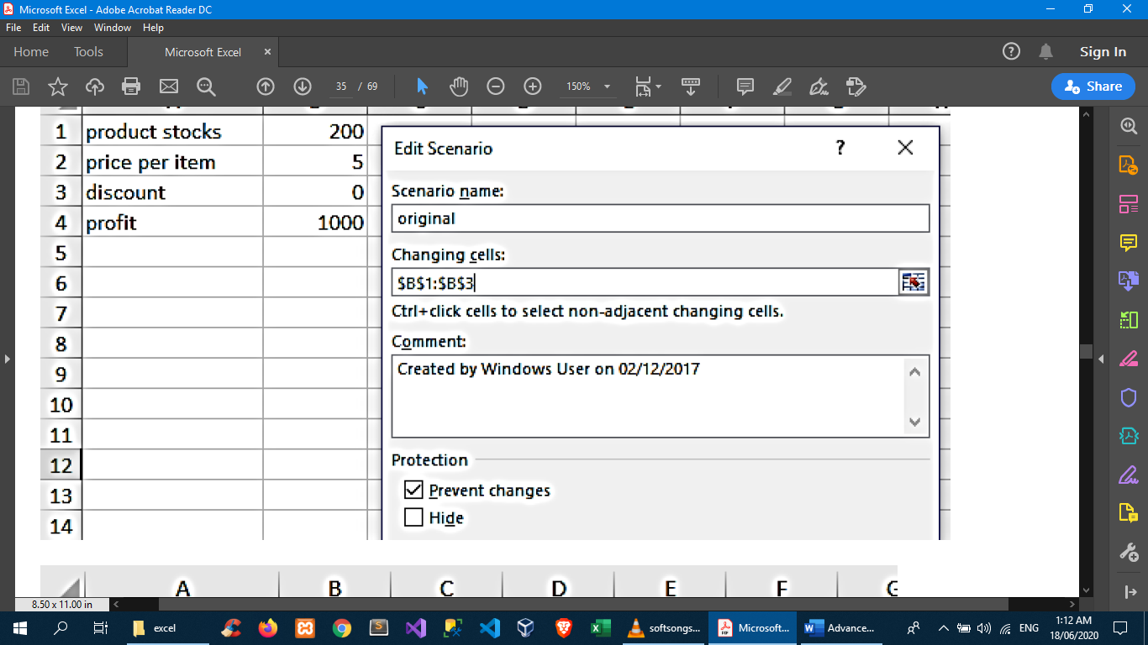

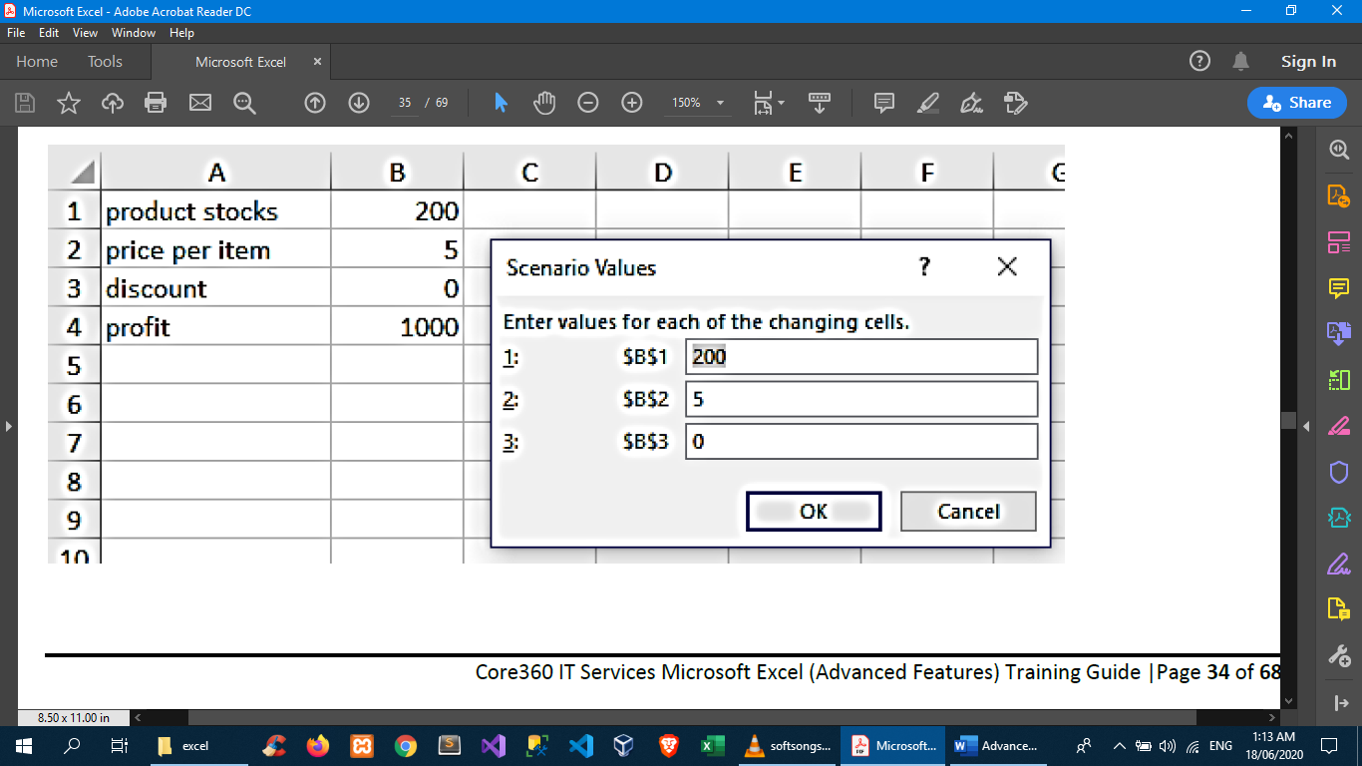

🡪add more scenarios

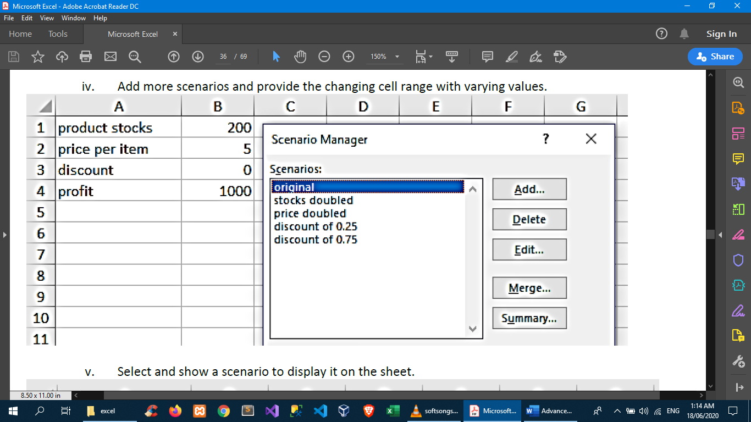

1. Goal seek

Provides a what-if analysis for generating computation factors for a given variety of answers (goals). This is commonly used when you are expecting results but do not know all the given factors to attain them.

🡪prepare data

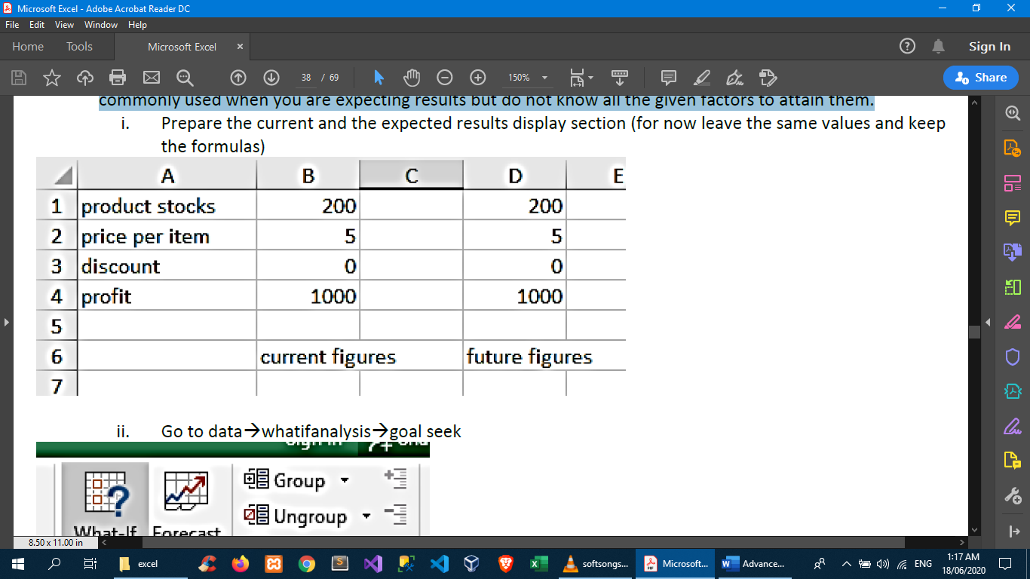

🡪data🡪whatifanalysis🡪goal seek

🡪provide value(s) for goal seel

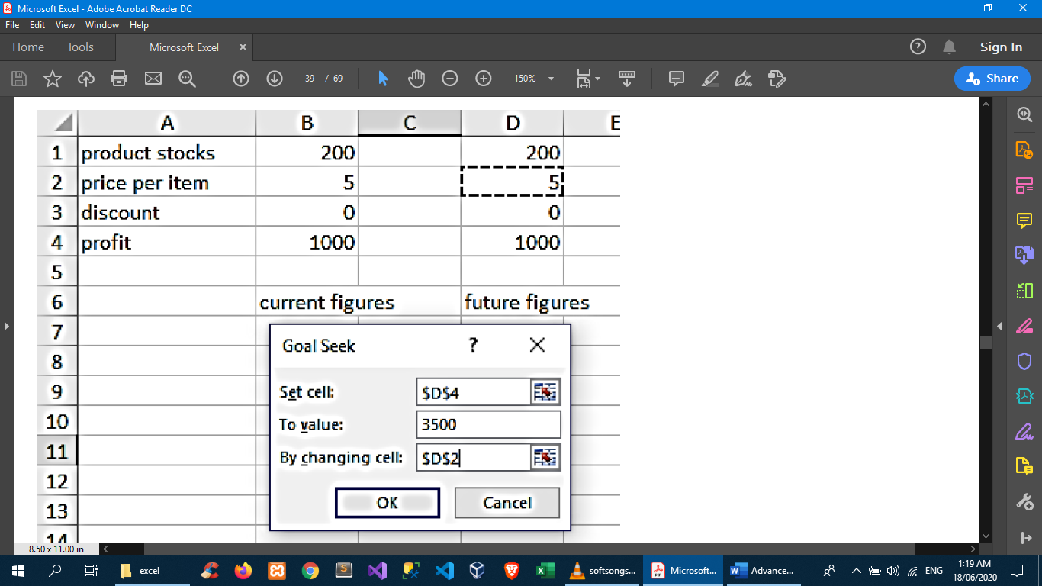

🡪Click OK then wait as goal seek finds a solution and display its answer

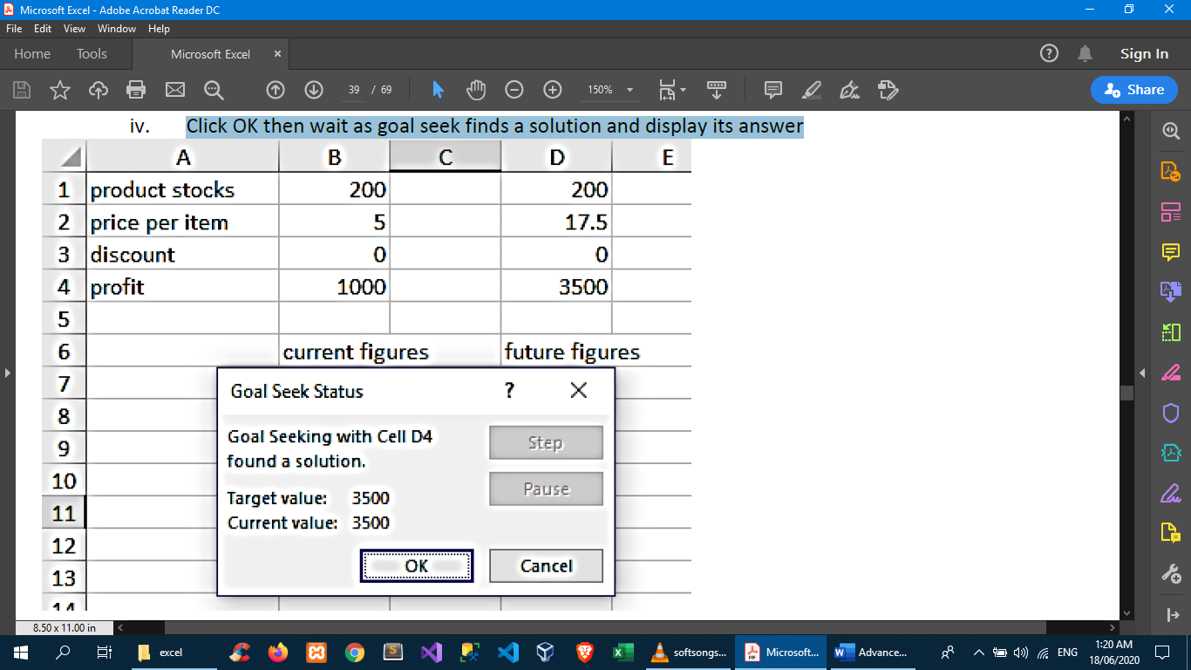

Import or export text (.txt or .csv) files

There are two ways to import data from a text file with Excel: you can open it in Excel, or you can import it as an external data range. To export data from Excel to a text file, use the Save As command and change the file type from the drop-down menu.

There are two commonly used text file formats:

1. Delimited text files (.txt), in which the TAB character (ASCII character code 009) typically separates each field of text.
2. Comma separated values text files (.csv), in which the comma character (,) typically separates each field of text.

You can change the separator character that is used in both delimited and .csv text files. This may be necessary to make sure that the import or export operation works the way that you want it to.

Note: You can import or export up to 1,048,576 rows and 16,384 columns.

